EPL Co-Editor Help Document
Contents
1.0 The Co-Editor Centre 3
2.0 Finding your way around an article 5
2.1 Notes 5
2.2 The information bar 6
2.3 Manuscript Information 8
2.3.1 The iThenticate report 9
2.4 Audit Trail 9
2.5 Manuscript Files: 10
3.0 Searching for and Inviting Referees on a New Article 10
3.1 Creating a new reviewer account 12
3.2 Different ways of searching for reviewers 12
3.2.1 Recommended/Opposed reviewers 12
3.2.2 Publons Referee Connect 13
3.2.3 Searching by reviewer name 14
3.2.4 The ‘Quick Search’ 15
3.2.5 The ‘Advanced Search’: 15
3.2.6 Searching by Keywords and “Wildcards”: 17
3.2.5 Searching by related papers 19
3.2.7 Searching by your Co-Editor History: 20
3.3 Reviewer information 22
3.4 Adding reviewers to the article 23
4.0 Making a Recommendation 23
4.1 How many reports do we require before making a recommendation? 23
4.2 Explaining the Make Decision screen 25
4.3 Making a recommendation 27
4.3.1 Making a recommendation – rejecting without sending article for peer-review 29
4.4 What if I am unable to make a recommendation based on the reports received? 29
5.0 Revised Articles 30
5.1 Revised Articles – Making a recommendation 34
6.0 For Information - New Articles and For Information - Revised Articles 36
7.0 What if I need more help? 36
8.0 Appendix - Decision emails 38
8.1 Acceptance emails 38
8.1.1 Provisional acceptance: 38
8.1.2 Formal Accept: 39
8.1.3 Accept without review: 40
8.2 Revision Emails: 41
8.2.1 Minor Revision: 41
8.2.2 Moderate Revision: 43
8.3 Rejection Emails: 47
8.3.1 Reject to Resubmit: 47
8.4 Reject without review emails 50
8.4.1 Reject without review (quality): 50
8.4.2 Reject without review (scope): 51
8.4.3 Reject without review (Poor English): 52
8.4.4 Reject without review (iThenticate/plagiarism): 53
8.5 Reject and Transfer 53
9.0 Appendix - the iThenticate report 56
9.1 Abstract 56
9.2 Introduction 56
9.3 Method 56
9.4 Results and Discussion 56
9.5 Conclusions 56
10.0 Appendix - Searching by Keywords: 58
10.1 Searching keywords, example one: ‘Relativistic wave equations’ 58
10.1.1 Exact match 58
10.1.2 Trailing wildcard 59
10.1.3 Leading wildcard 59
10.1.4 Combined wildcard search 60
10.2 Searching keywords, example two: ‘Perturbation theory’ 61
10.2.1 Exact match 61
10.2.2 Trailing wildcard 62
10.2.3 Leading wildcard 63
10.2.4 Combined wildcard search 64

1.0 The Co-Editor Centre

When an article is submitted to the journal and assigned to you as a Co-Editor, you will receive an email asking you to assess the suitability of the manuscript and manage the peer review process for it. By managing the peer review process, we are essentially asking you to select appropriate referees/reviewers and to make the publishing decisions that are required during the peer review process.
When you receive the email, if you cannot manage the review process for the article please contact your Admin support at editorial.office@epletters.net as soon as you can so that they can reassign the article to an alternative Co-Editor. If possible, please also suggest Co-Editors who you think could act as an alternative.
Firstly, after being assigned an article by the EPL admin, you will need to access your ‘Co-Editor Centre’ by following the links in the email to the ScholarOne Log In screen (shown below):
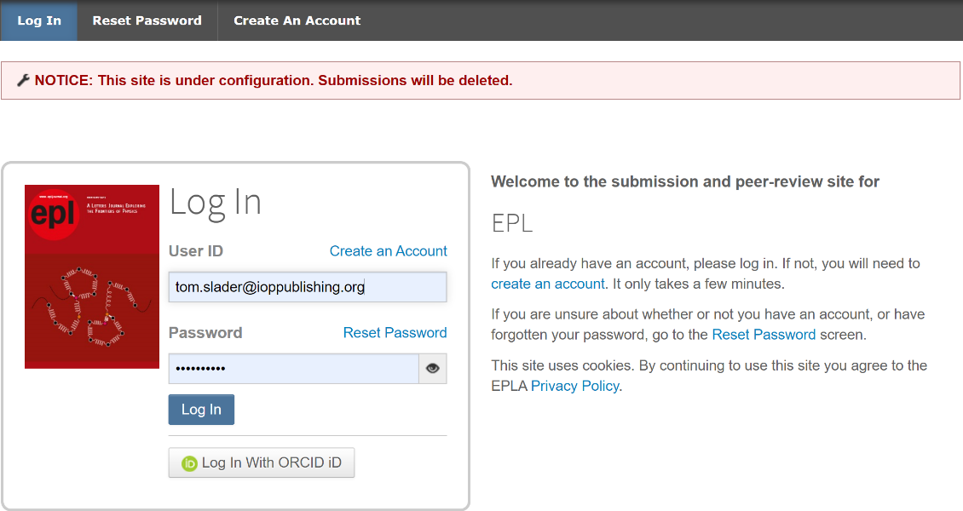
Once you have gained access you will see the screen shown below. Click on the ‘Co-Editor’ role from the ‘Manage’ dropdown box.
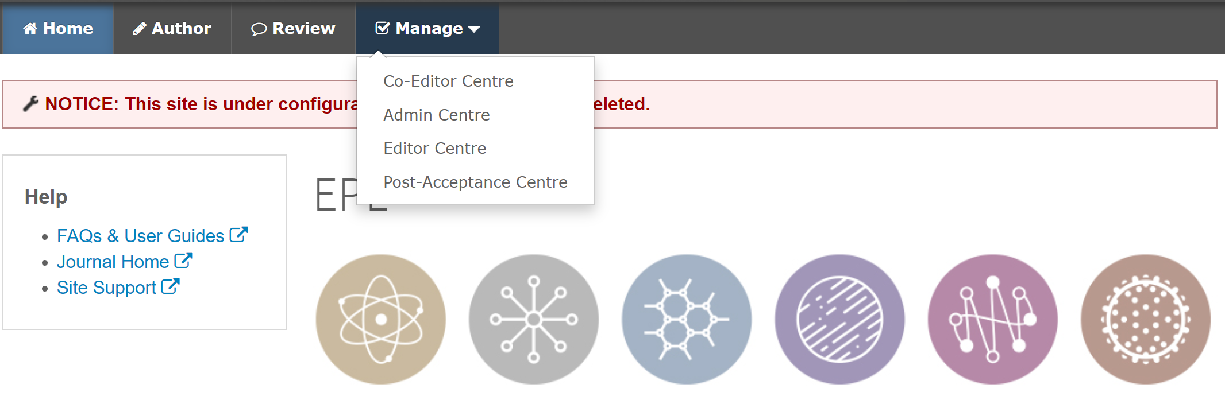

You will now see your Co-Editor ‘dashboard’
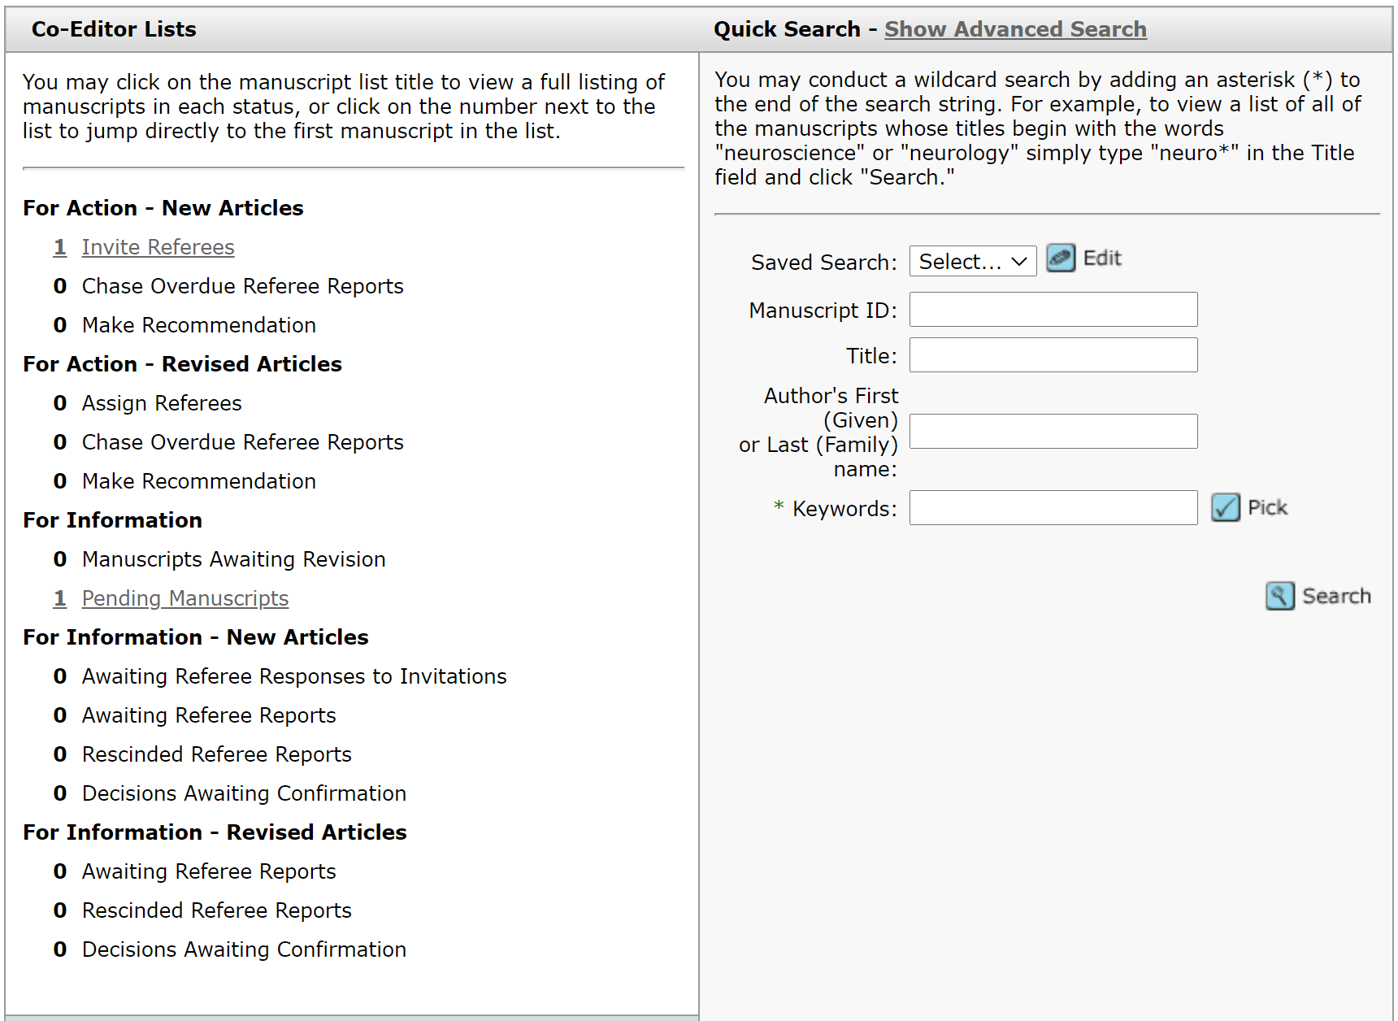
On the left-hand side is the menu which lists any articles that require your action (in the above example you can see that there is one new article which requires reviewer selection).
To access the list of articles that require your attention, click on the appropriate link, for example ‘Invite Referees’. You will then be able to see any articles which require action (as shown in the example below):
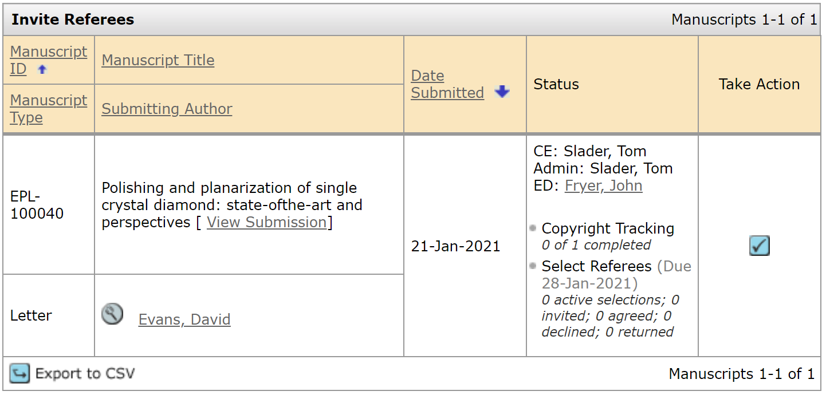
Please note that the system will automatically highlight any ‘overdue’ articles that should be prioritised over other articles appearing on the list.
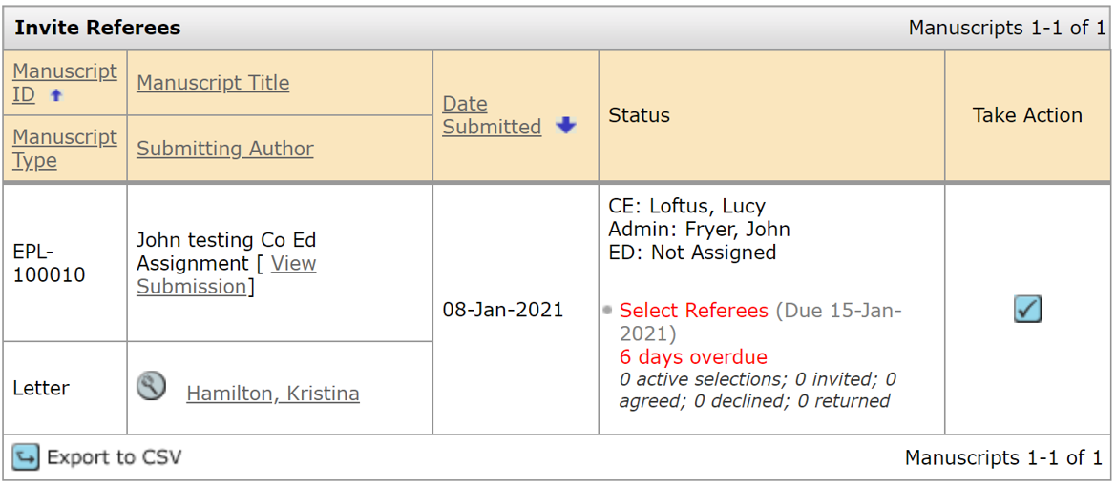
Any overdue articles on the list will be highlighted in red
To access an individual article, click on the blue ‘take action’ button on the right-hand side.

2.0 Finding your way around an article

After accessing the article, click the ‘Manuscript Information’ tab to view the main article page and the author supplied information:
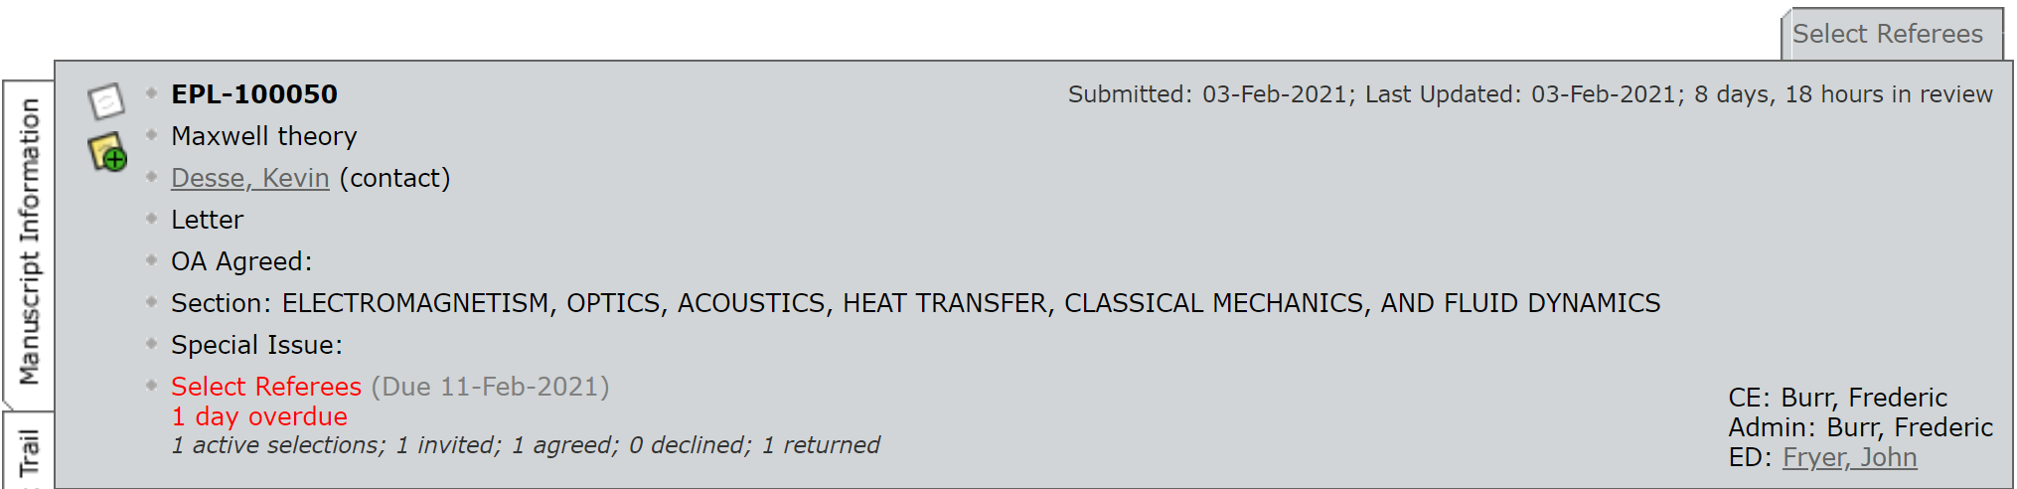

2.1 Notes
It is always advisable to check for any ‘Notes’ that have been made on the article by the EPL Admin during their initial check of the article. These appear at the very bottom of the screen. Clicking on the note icon will take you directly to the notes section at the bottom of the page. Any notes that are for your attention will have the heading ‘FAO CE’, as in the example below.
There is a note icon in the top left (indicated below)
- If this is white (as shown), no notes have been added.
- If this is yellow, a note has been added to the article.
- If this is yellow with a purple circle – a new note was added very recently.
Clicking on the note icon will take you directly to the notes section at the bottom of the page.
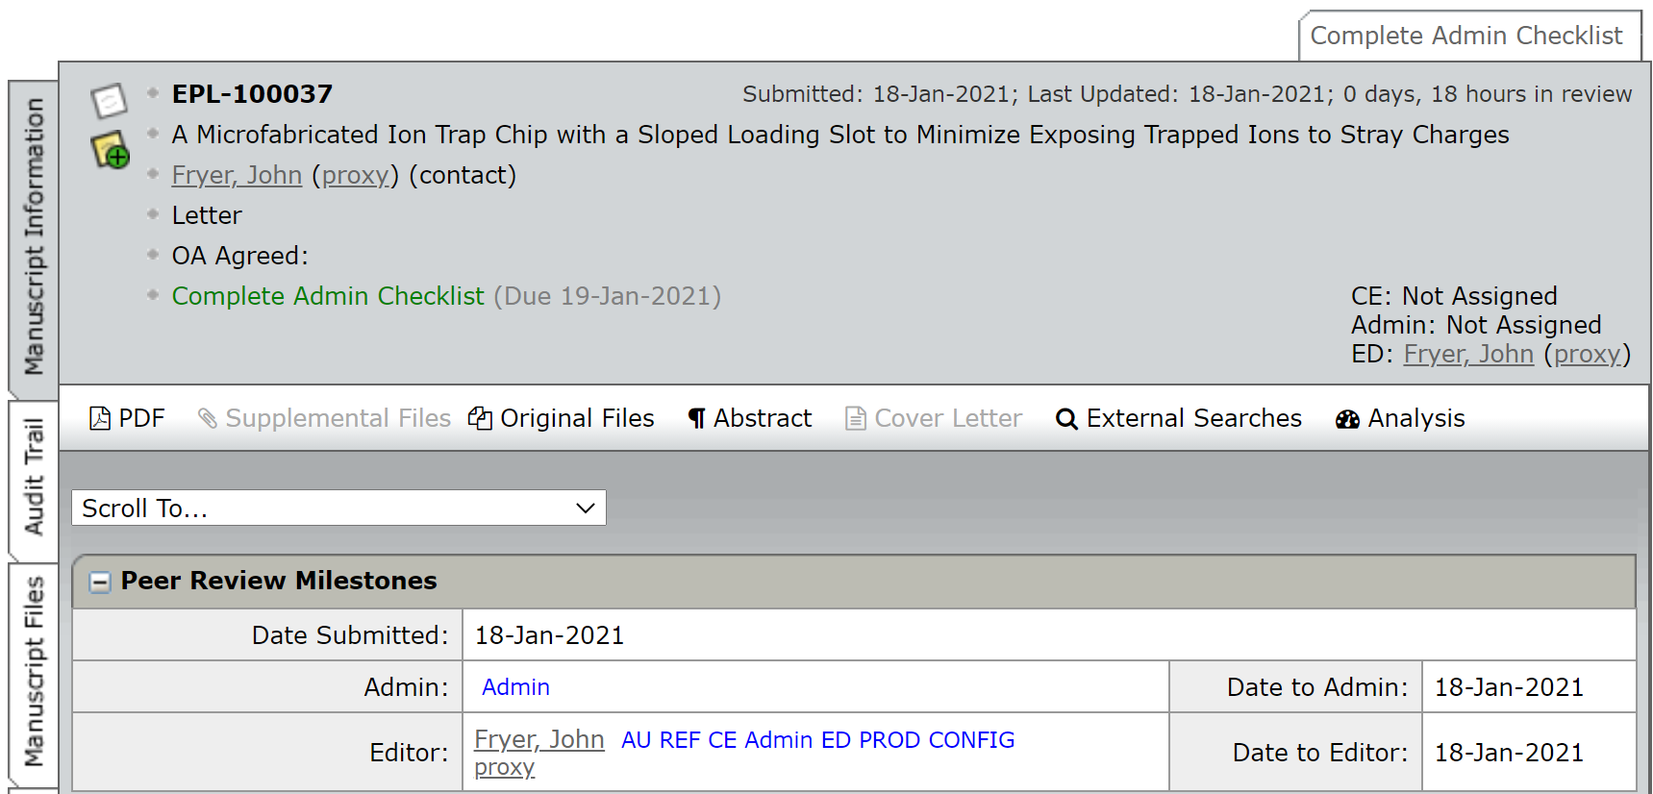
To read the note, click on the note title link on the left-hand side.
Once you have read the note, clicking on the ‘top’ button located on the right which will return you to the top of the screen.
You can add your own notes by clicking ‘Add note’. We recommend that you title your notes ‘FAO Admin’.
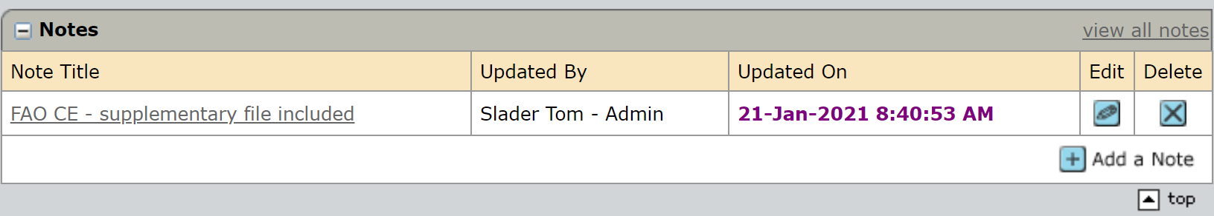

2.2 The information bar
Across the information bar located at the top of the screen you will see article information including the article reference number, the title, the list of authors, and the article type:
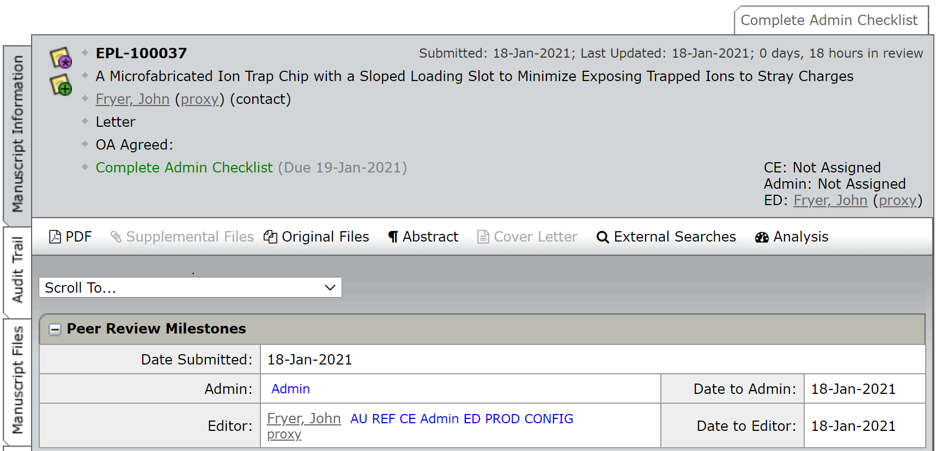
You can also see some ‘shortcut buttons’.
Click on any one of these buttons in order to access the information.
- ‘PDF’ will open a PDF of the article
- ‘Supplementary Files’ opens any separate file which is associated with the article and will eventually be published online
(note that in the above example the button is ‘greyed out’ as there is no supplementary file associated with this article – if there was the button would be in bold like the other shortcut buttons in this example)
- Original Files will allow you to see all original files uploaded with the article.
- ‘Abstract’ will allow you to read the abstract provided by the author
- ‘Cover Letter’ allows you to access the authors cover letter.
- ‘External Searches’ enables you to take key article information and search using existing tools like Google and Web of Science.
- The iThenticate report (an explanation is given below in section: 2.3.1 The iThenticate report)
On the left-hand side of the screen you will see three tabs labelled ‘Manuscript Information’, ‘Audit Trail’ and ‘Manuscript Files’ (see below).
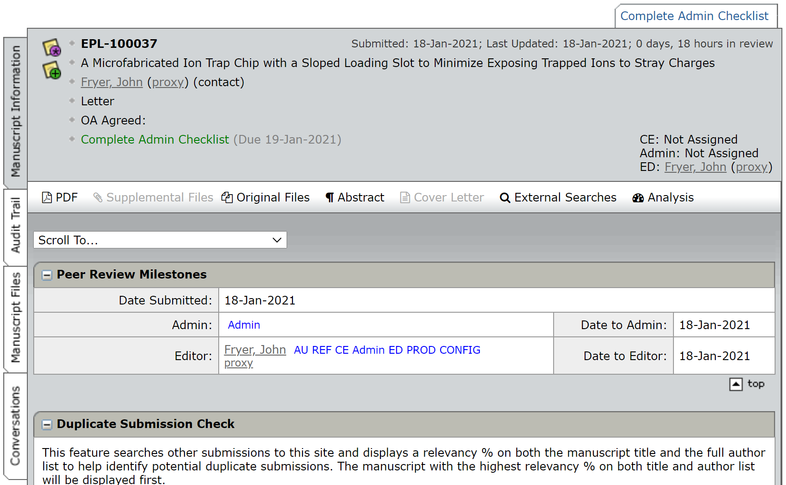

2.3 Manuscript Information
Click on Manuscript Information and you will see a different view of the article information, including the title, article type, manuscript ID number, list of authors, keywords (as entered by the author), the research type of the article as entered by the author, any reviewers recommended or opposed by the author and a copy of their cover letter – see below.
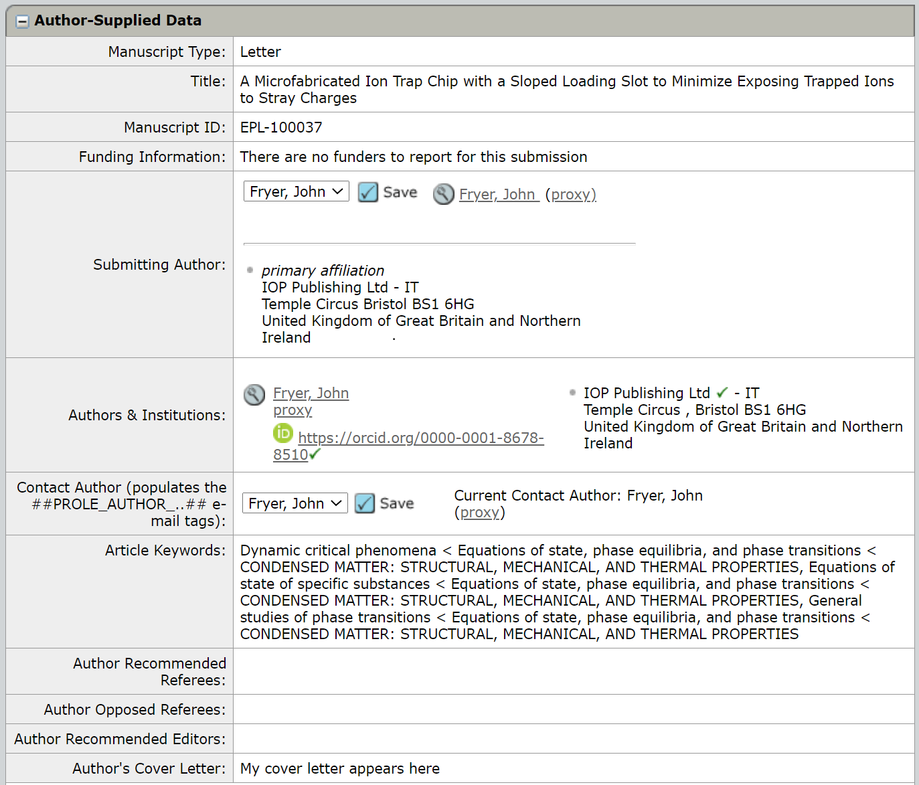

2.3.1 The iThenticate report
iThenticate is a service that EPL uses to detect instances of plagiarism in New Submissions. The EPL admin will add a Note to the article to bring to your attention if iThenticate flags that a New Submission has a high percentage of content from another article:
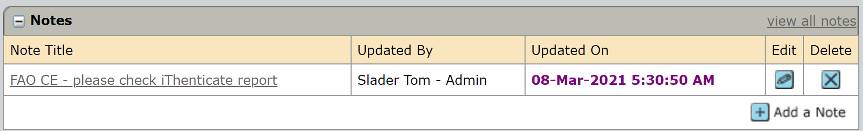
You can view the report by clicking ‘View the Originality Report’ link:
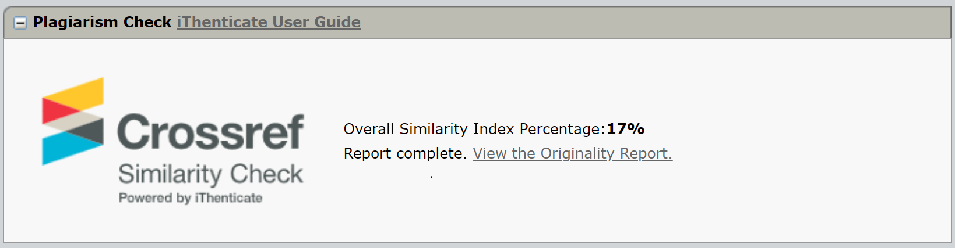
Please use the report to judge whether the overlap with the highlighted articles is too high and therefore the new submission should be rejected. To reject the article due to the iThenticate report, please see section ‘4.3.1 Making a recommendation – rejecting without sending article for peer-review’ for rejecting the article.
A guide to assessing the iThenticate report can be found in the Appendix (9.0 Appendix – the iThenticate report. If you have any questions about the report, please contact the EPL Admin (editorial.office@epletters.net).

2.4 Audit Trail
Clicking the ‘Audit Trail’ tab will allow you to view previous actions and emails that have been performed on the article. In the screenshot below you can see that the article was assigned to a Co-Editor and that the reviewer selection task became pending. You can read emails sent by clicking the letter icon:
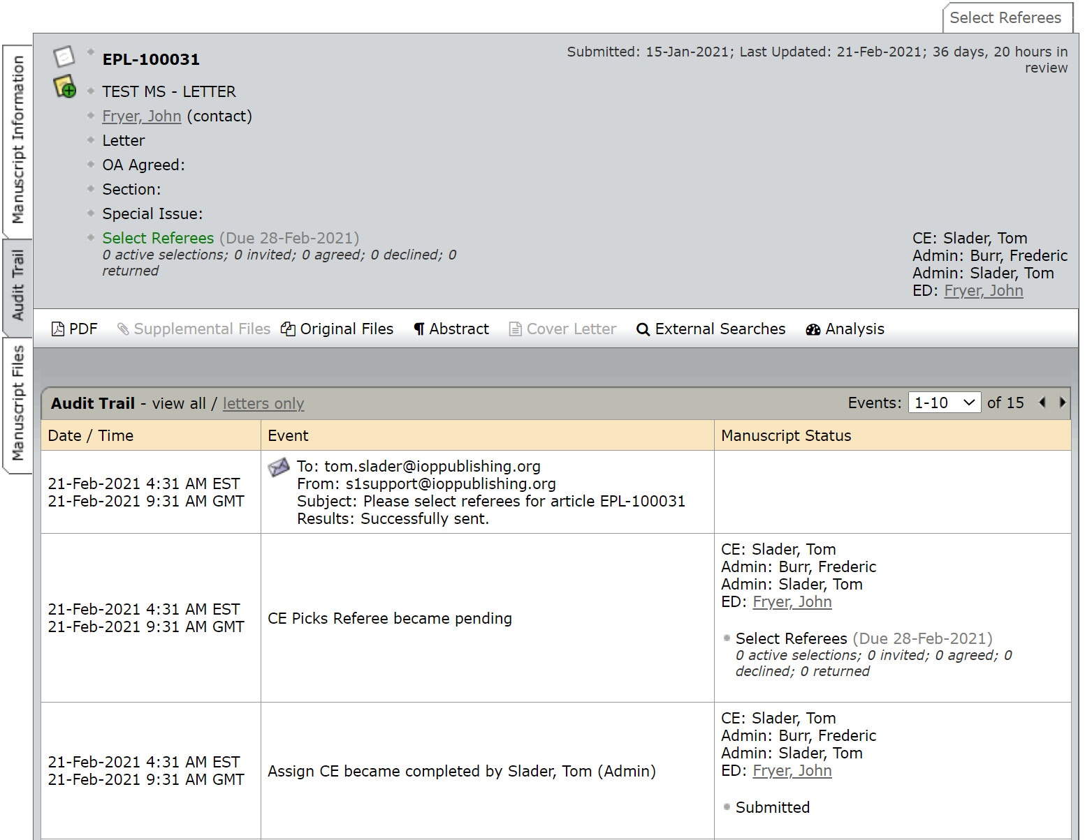

2.5 Manuscript Files:
Here you will be able to view files that have been uploaded by the authors. However, it is not necessary to view files here as they will be available to you by clicking in the information bar at the top of the page. You can see that a PDF of the article has been uploaded – we do not recommend that you click any of the buttons on this page (‘Edit Details’ or ‘Delete’):
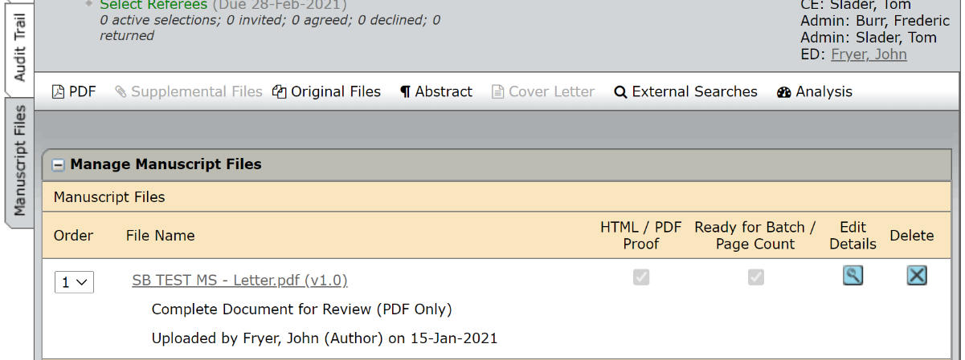

3.0 Searching for and Inviting Referees on a New Article

Before beginning your search, you need to ensure that you are in the correct view. Click on the ‘Select Referees’ tab located on the top-right hand side of the article page.
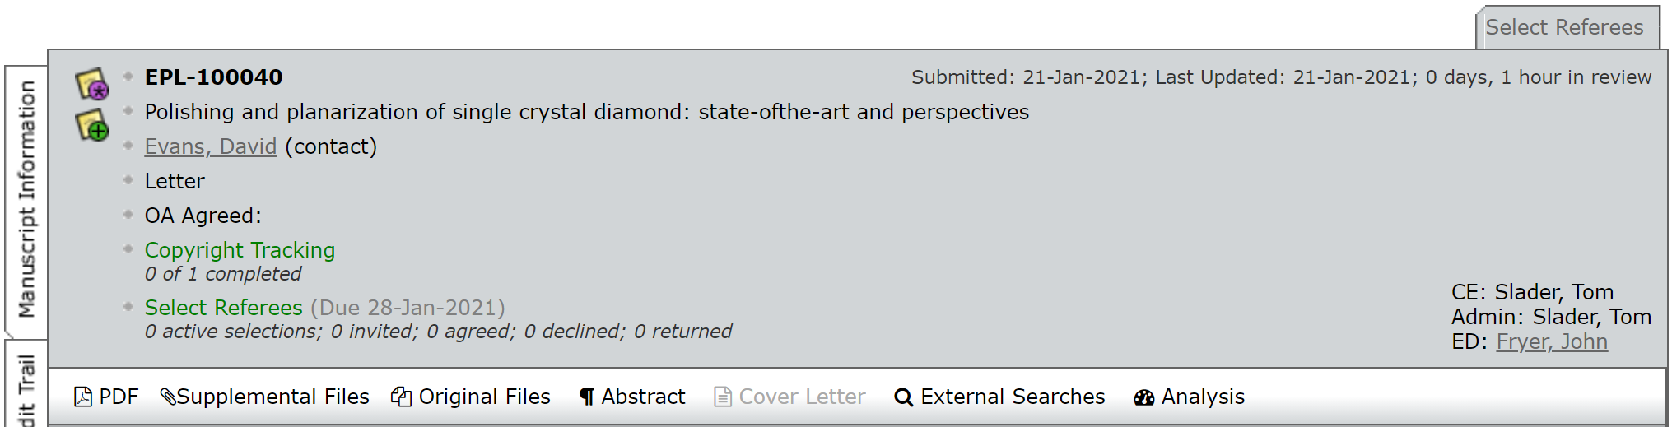
Key things to remember!
When searching for a potential reviewer you are searching a database – it does not contain the contact details of everyone so you may need to add a new reviewer if they are not already on the database or ask the Editorial Office to add them for you.
- Where possible it is advisable to select multiple reviewers. This helps when an invited reviewer has declined to report or does not respond as it means there is an alternative reviewer that can easily be invited.
- Try to avoid inviting reviewers who are at same institution as the authors and co-authors (or simultaneously inviting two different reviewers who are at the same institution as each other) to avoid any potential conflict of interest.
As you add referees to an article they will appear in the ‘Referee List’;
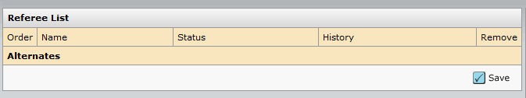
To the right of the Reviewer List is a Progress indicator, showing the number of reviews required to make a recommendation. It will default to ‘2’ reviewers required.
If you would like to make a recommendation on an article without sending it to any reviewers, you can change the ‘# reviews required to make decision’ to ‘0’ then click on ‘Save’. This will allow you to make a recommendation on the article.
Please go to page 22 and 27 for an explanation of how to make a recommendation (or contact the Editorial Office for guidance - editorial.office@epletters.net).

3.1 Creating a new reviewer account
You may need to create a new account for a reviewer who is not present in the EPL database.
Click the ‘Create Reviewer Account’ function located towards the top of the screen on the right-hand side (see below).

You will need to complete the ‘required fields’ (req) in order to create a new account. If you wish to include the institution and department then click on the ‘Provide more account info’ link.
Once you are ready to create the account click on the blue ‘Create and Add’ button. This will add the referee to the ‘Reviewer List’.
If you are unsure of how to add a reviewer or if you think that the reviewer is in the EPL database, but you cannot find them, please email the EPL admin team for assistance (editorial.office@epletters.net).

3.2 Different ways of searching for reviewers
There are multiple ways of searching for reviewers in ScholarOne, including the authors’ recommended (or opposed reviewers), by using the Publons database, and by searching through EPL’s reviewer pool (Quick Search, Related Papers and the Advanced Search).
Please carefully read through the below guide before making your selections.

3.2.1 Recommended/Opposed reviewers

- These are suggested by the author at submission stage
- Authors do not always specify why a referee is “Recommended”. It could be that they are the experts in the field, but some less scrupulous authors may be recommending friendly colleagues.
- If there isn’t a ‘magnifying glass’ icon next to their name, they are not on the database.
The Recommended/Opposed reviewers section is located near the top of the screen, as shown below;

The Recommended/Opposed reviewers section is located just below the Reviewer List

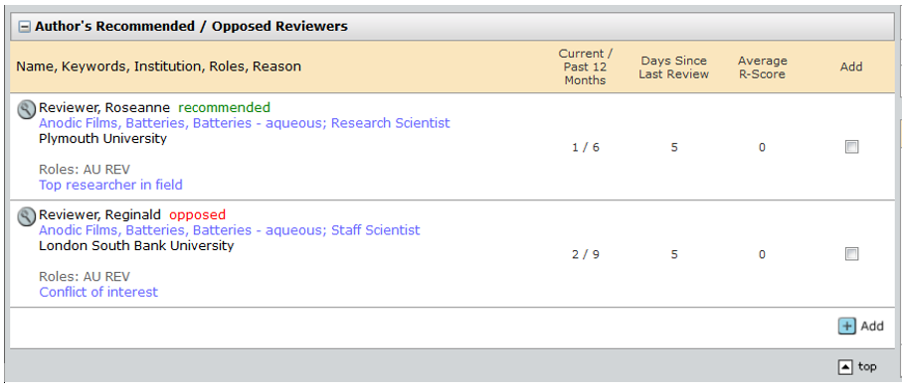

To the right of the reviewers name you can see information on whether they already have another article, how many articles they have reviewed in the past 12 months, the number of days since they last reviewed and the average ‘R’ score – which is an indicator of the quality of reviews they have submitted in the past.
If you wish to use any of the reviewers recommended by the authors, tick the box to the right of their name and then click on the blue ‘Add’ button. Remember, if they do not have a magnifying glass icon next to their name you will not be able to select them as they are not on our database. You will need to create an account for them if you would still like to use them or alternatively contact the EPL Admin who can add them to the database for you (editorial.office@epletters.net).

3.2.2 Publons Referee Connect
- This is a semi-automated search linked to the ‘Publons’ review database. The manuscript title is compared to Web of Science entries and the search returns potential reviewers based on this – it also shows verified reviews by the reviewer.
- The search can return some unrelated results so we advise using caution and doing research on the suggestion before adding a reviewer from the tool.
- If there isn’t a magnifying glass next to their name, they are not on the database.

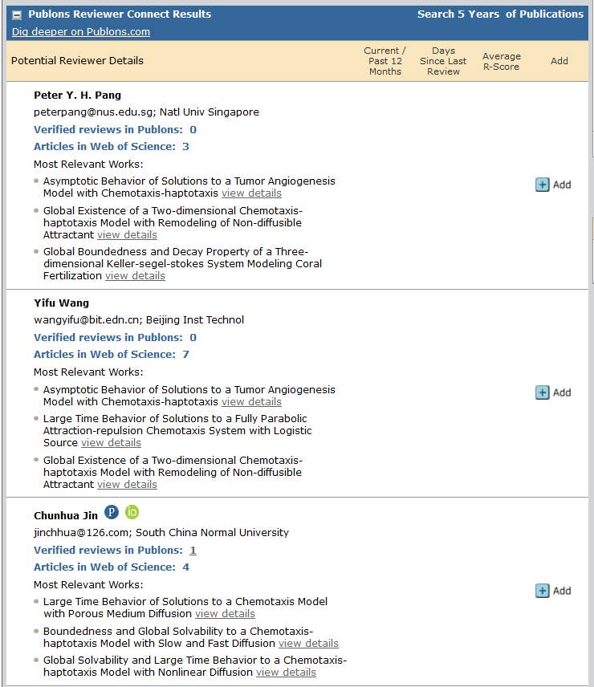

If you wish to use any referees from this list, click on the blue ‘Add’ button to the right of the referee details. If they do not already have an existing account then you will be prompted to create an account for them when you click on the ‘Add’ button. If you would like any assistance on creating an account, please contact the Editorial Office and ask them to do it for you.

3.2.3 Searching by reviewer name
There are multiple ways of doing this:
Method | Pros | Cons
Quick search | Searches both first and surnames  Works well for unique names | If searching common names (e.g. Smith), will return high numbers
Advanced search | Separates out first name and last name  Can also search for email | Only returns names which match *all* entered fields

TIP: these searches are searching our database, as the referee entered their details. So, John Smith may be in our database, but as J Smith. If putting full first name in doesn’t return a name, try the initial and a wildcard (i.e. First Name: J* Surname: Smith will return J Smith, Jane Smith, James Smith… John Smith).

3.2.4 The ‘Quick Search’
Type either the first (given) or last (family) name in the search box, then click on ‘Search’.
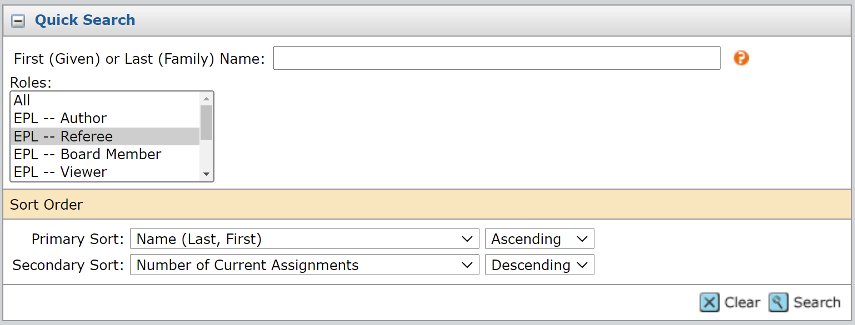

3.2.5 The ‘Advanced Search’:
This search allows you to enter more detailed information when searching
If you wish to add anyone from the results list, tick the box to the right of their name before clicking on the blue ‘Add’ button (see below).
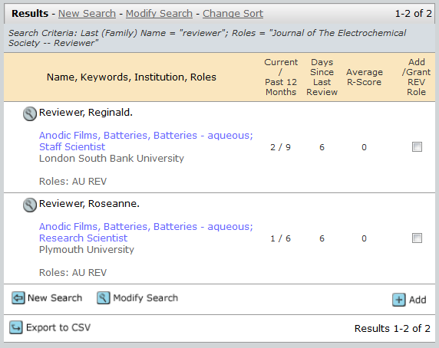

3.2.6 Searching by Keywords and “Wildcards”:
- Use the “Keywords” (left-hand-side) box (shown below)
- This searches the keywords that have been entered into the reviewers’ account (it will find reviewers that have information entered in keywords section on their contact record.
- Does Boolean (AND OR), takes wild cards (*) and exact terms (“error estimate”)
- This is a more advanced feature

You can search using keywords in both the Related Paper search and the Advanced Search.

The keywords that you use to search for reviewers can be taken from the ‘Author Supplied Data’ on the ‘Manuscript Information’ page:

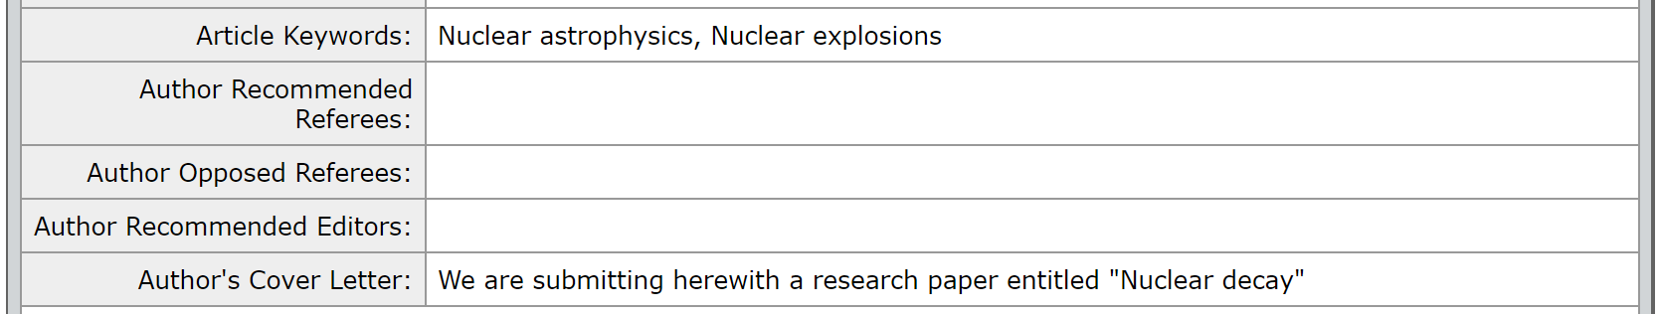

For example, the terms ‘nuclear’, ‘explosion’ and ‘nuclear explosion’ have been entered into the Keywords field by the authors.
Input the keywords into the search fields as shown below (after clicking back into the ‘Select Referees’ tab):

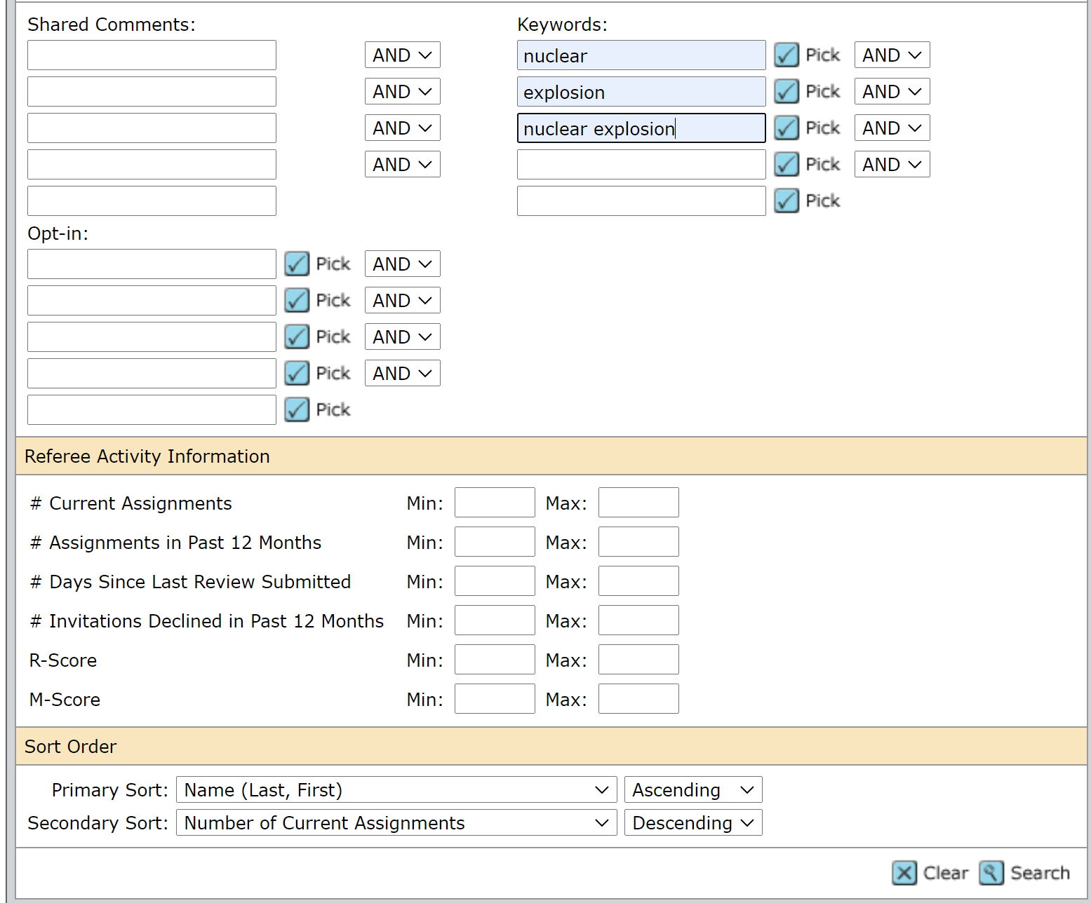

The search can be refined by adding Wildcards
To perform a multiple character wildcard search (i.e. to find 0 or more characters) use the asterisk (*) symbol.

For example, to search for the keywords test, tests or tester, you can use: test*

Exact match = nuclear explosion – Won’t find nuclear and explosion
Partial match = nuclear explosion* - all accounts that have nuclear explosion
Part of search term = *Nuclear explosion*.

e.g. Search for *Nuclear* AND *Explosion* to find profiles that have nuclear and explosions as Keywords.

After clicking Search and bringing up the results, if you wish to add anyone from the results list, tick the box to the right of their name before clicking on the blue ‘Add’ button which appears at the end of the results list.

Please see ‘10.0 Appendix: Searching by Keywords’ for a more detailed guide and examples of searching using keywords and wildcards.

3.2.5 Searching by related papers
This search function will enable you to search for authors and reviewers of articles similar to the one you are selecting reviewers for. This will enable you to select reviewers you know have experience with this type of article (either through previous reviews or having written an article in a similar field.
As you may not know the exact title of previous papers, we recommend that you add article Keywords to the search:
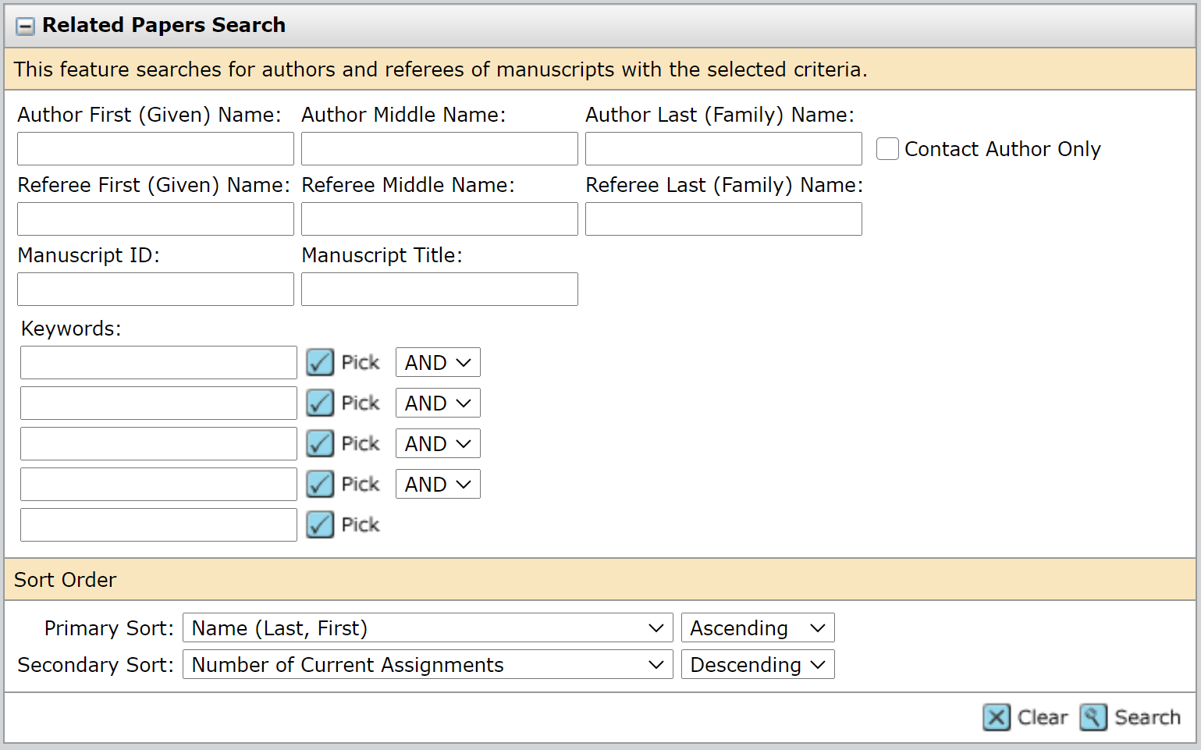
Keywords can be searched similarly to the above guide on page 16, by using the keywords from the ‘Author Supplied Data’ section of the ‘Manuscript Information’.
You can also search for related papers using author or reviewer names, the manuscript IDs of articles.
Searching by author name will bring up a list of articles that the author has submitted, both as the corresponding author and as the co-author (Fred Burr has again been used as an example):
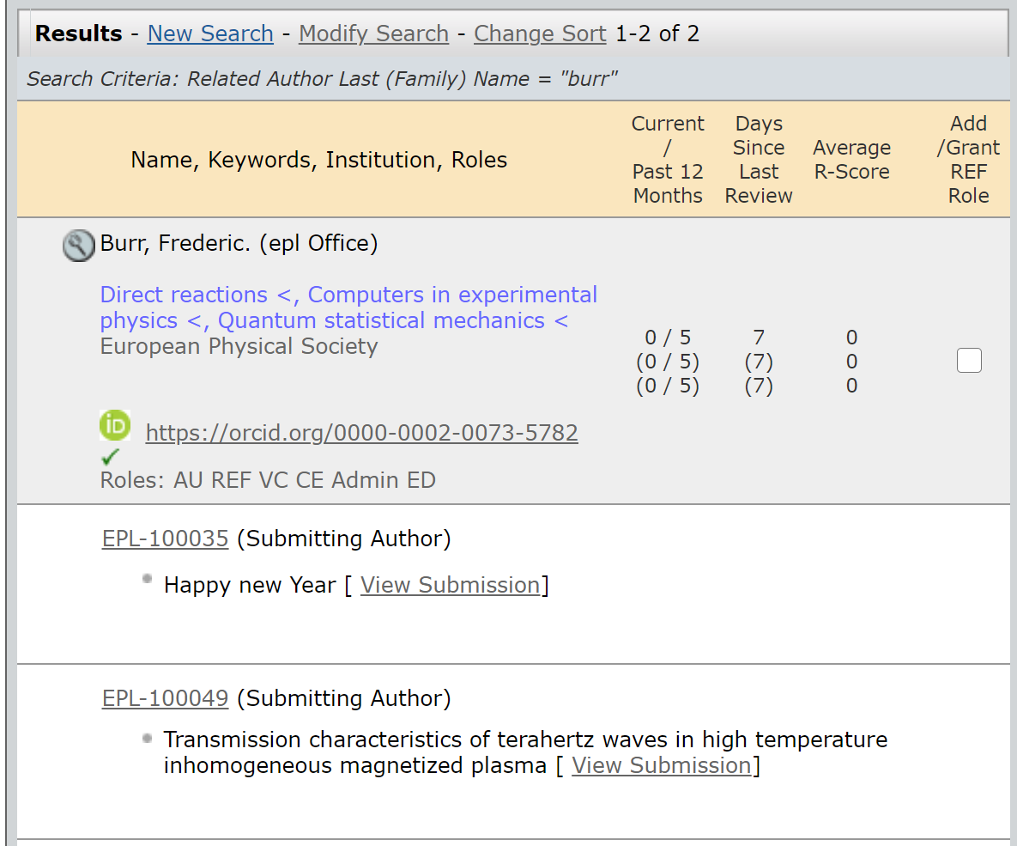
The previous articles can be viewed by clicking on the article ID hyperlink. This will take you directly to the article, where you can see the full article, including the previous reviewers).
You will need to click on the article ID of the article that you are selecting reviewers for to get back to the reviewer search once you have viewed the previous submission:
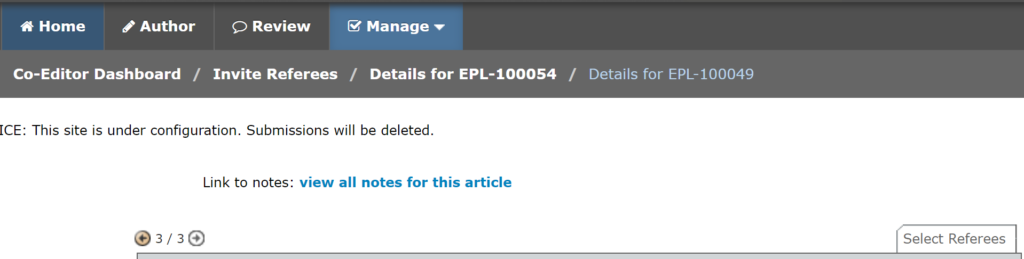

3.2.7 Searching by your Co-Editor History:
It may be useful to search for your own account and view articles where you acted as the Co-Editor. To do this, add your surname to the ‘Quick Search’ search bar (in this example we are using Fred Burr) and select Co-Editor in the ‘Roles’ section and click ‘Search’:

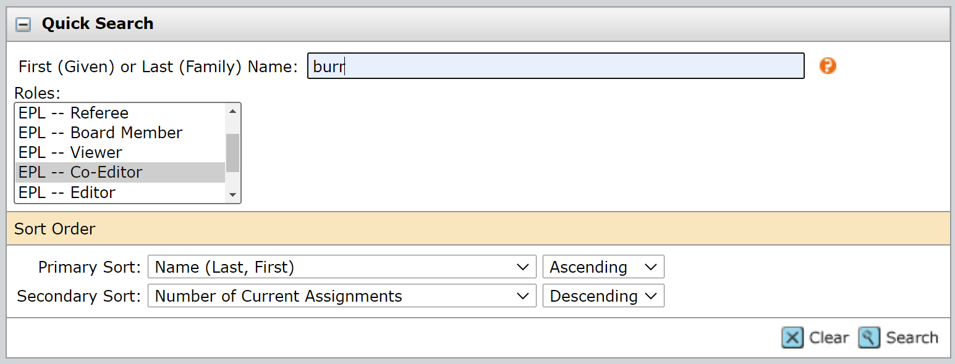

Your account will then appear in the search results and you can view your previous articles by clicking on the magnifying glass image:

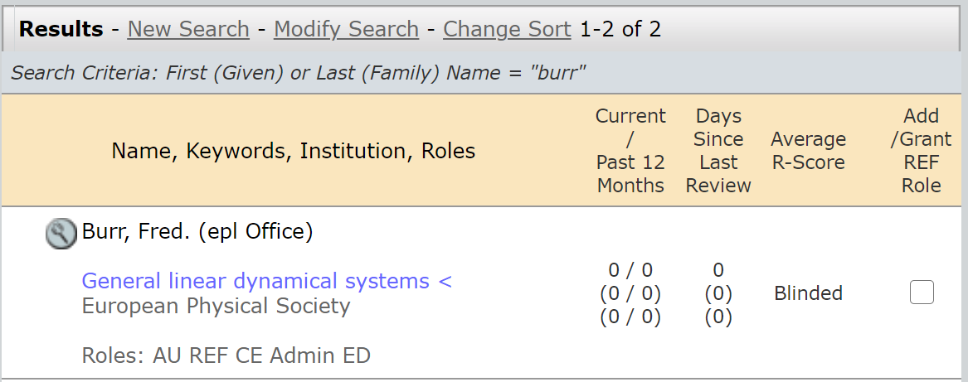

And then clicking the ‘CE History’ tab to see a list of the articles. Click on the article ID to view them:

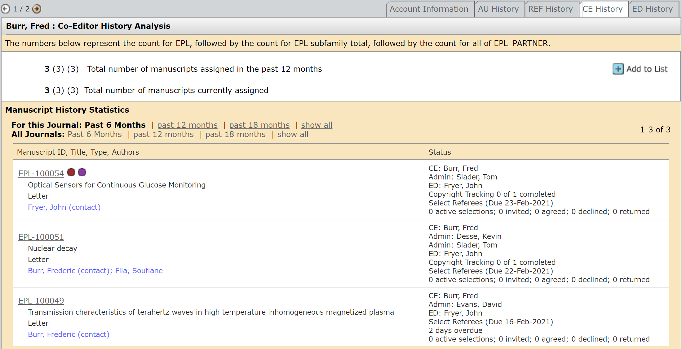
Running this search will help you to find reviewers who reported on similar articles to the one assigned to you.

3.3 Reviewer information

For any reviewer that has the magnifying glass icon next to their name, you can call up further information on them by clicking on the icon.

You will then see the below view in a pop-up window;

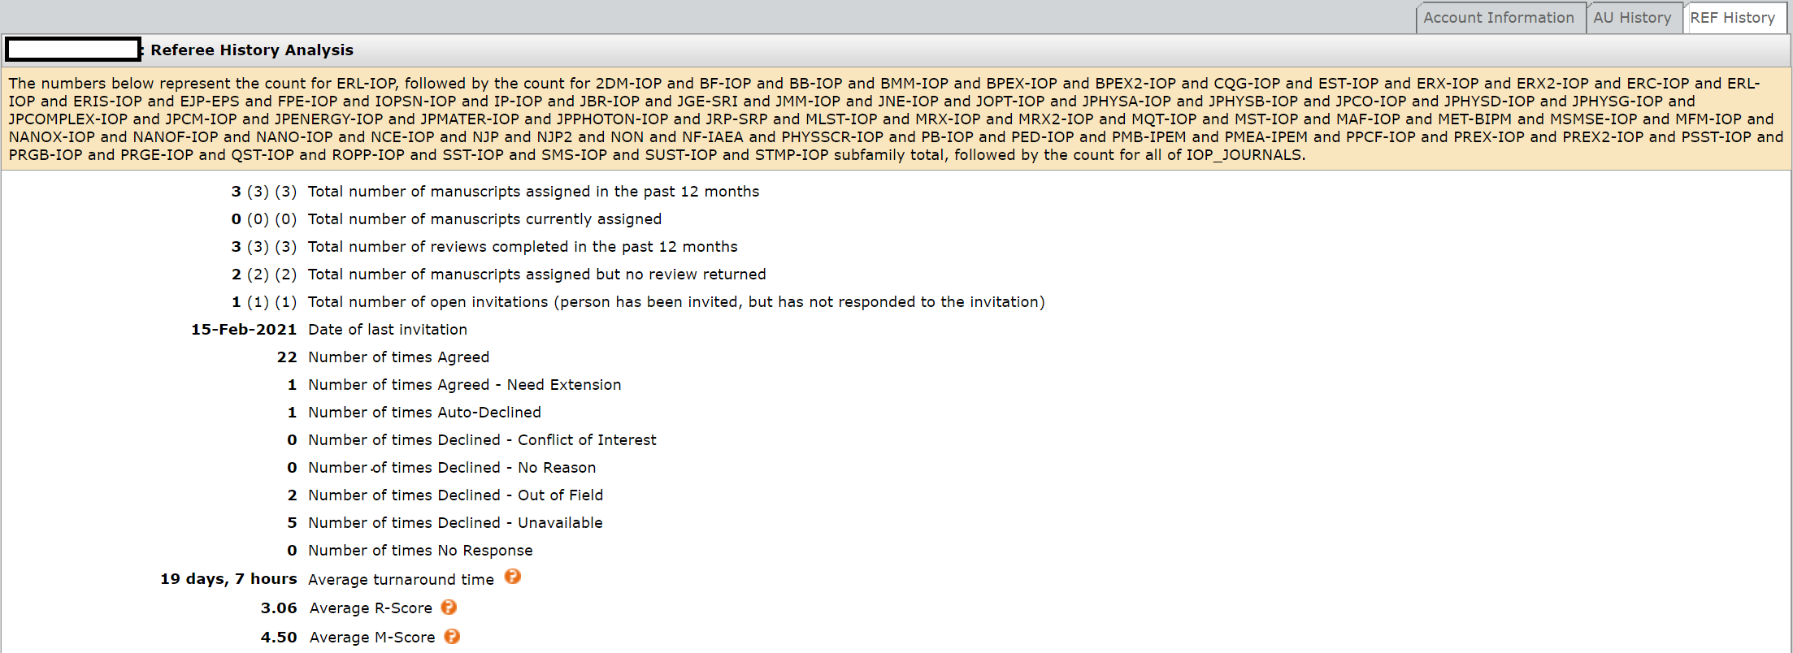

This information is useful for checking if a reviewer already has an article, when they were last invited to review an article etc.

After searching for reviewers and receiving the results, you will be able to see the same information displayed next to the reviewer’s name (as shown below). The R-Score is the average rating that the reviewer’s reports have been given by Co-Editors. Please note that reviewers who have not previously reported will not have an ‘R-Score’.
The higher the R-Score means that previous Co-Editors have rated the reviewer’s reports highly. The R-Score will be displayed in the reviewer’s account as below. You may want to avoid inviting reviewers who have a very low R-Score (the rating is out of 5. 5 is excellent, 3 satisfactory, and 1 is very poor):

3.4 Adding reviewers to the article
After you have found suitable reviewers to report on the article, you will need to add them. To do this, click on the tick box beneath the ‘Add/Grant REF Role’ heading and then click ‘Add’
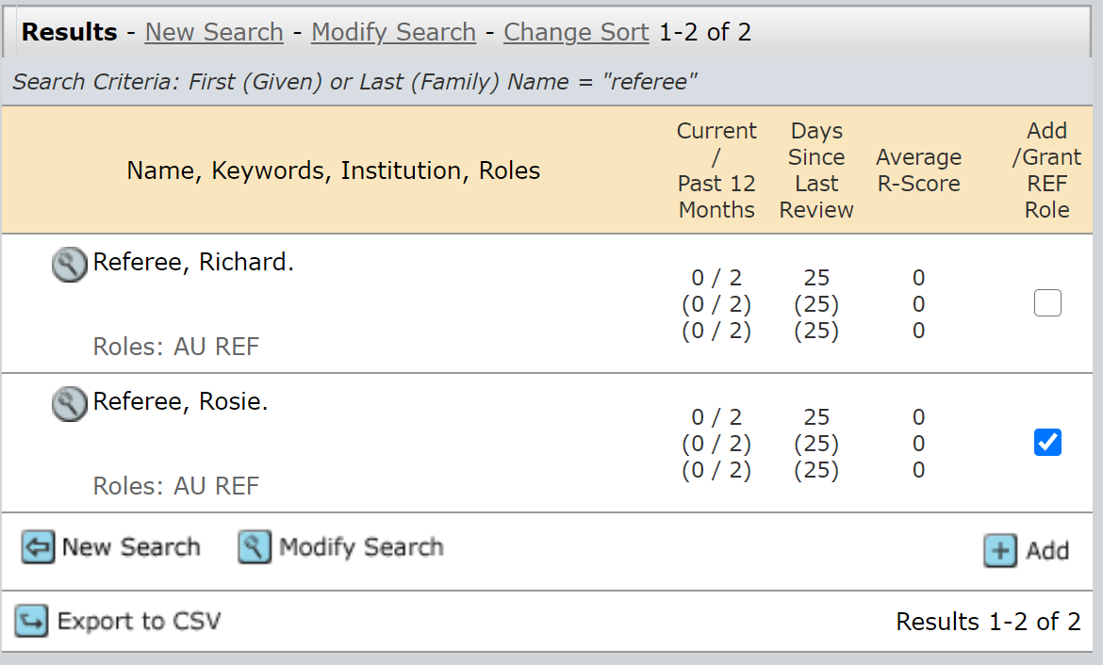
Once you have selected the required number of reviewers for the article, you can log out as your task is complete. The EPL Admin team will invite the reviewers to report.

NB: Please note that if you are searching for a referee and notice that their details are incorrect, or find a duplicate contact record on the system, please contact the EPL Admin at editorial.office@epletters.net so that they can make any corrections to the system that may be required.

4.0 Making a Recommendation

4.1 How many reports do we require before making a recommendation?
The system is set up to default to two reports being required (see page 11 for changing the number of reviewers required). Once we have received two referee reports then the article will automatically be redirected to your Co-Editor Centre and will appear in the ‘Make Recommendation’ part of your queue:
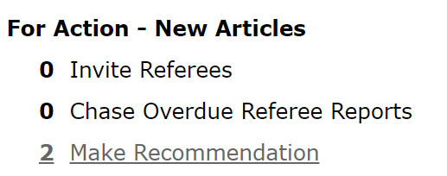
Click on the link to access the list of articles which require your recommendation. Click on the blue ‘Take Action’ button to access the article and view the referee reports:
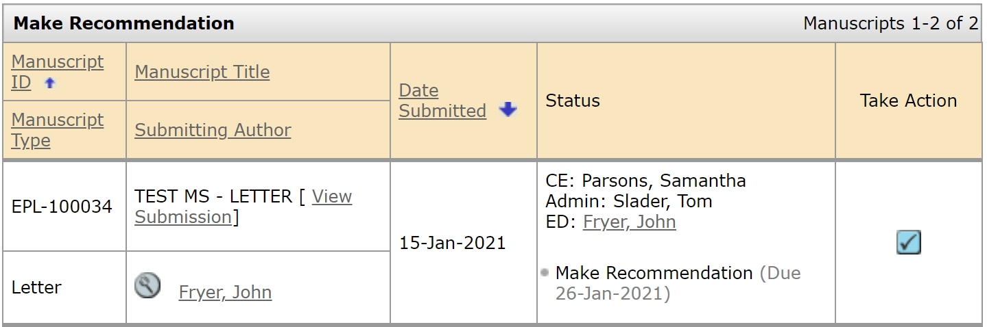
You will then be able to see the ‘Make Recommendation’ screen:
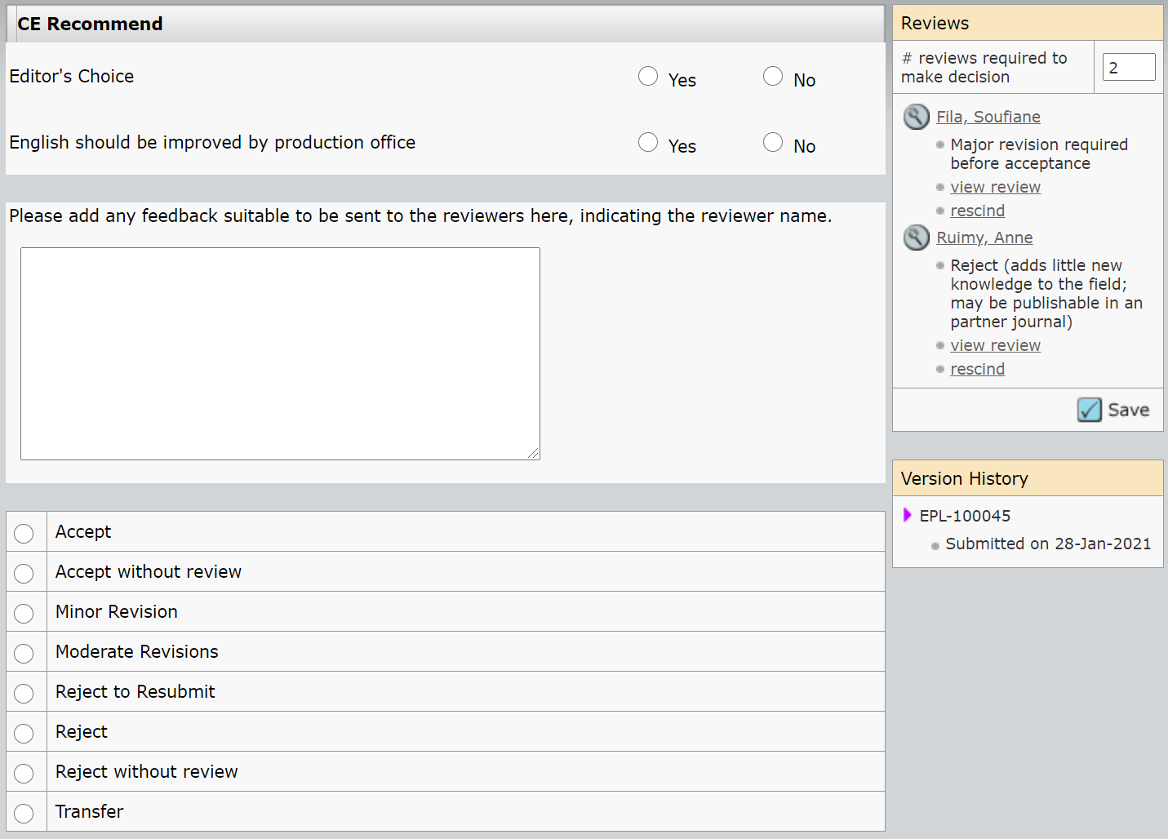
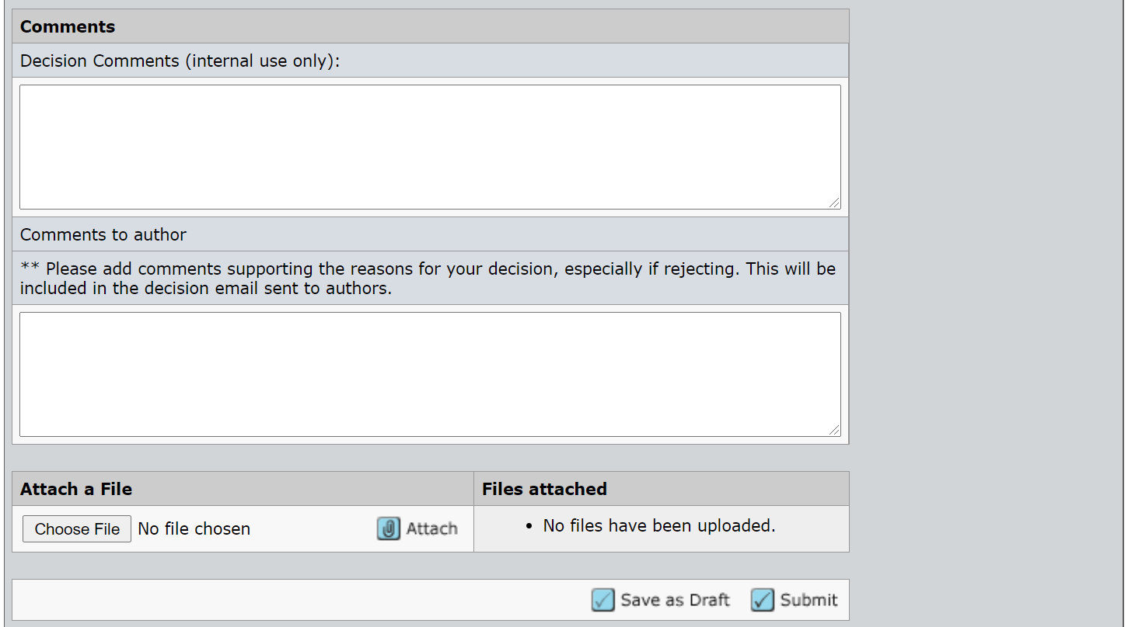

4.2 Explaining the Make Decision screen

CE Recommend: This section allows you to alert the EPL Admin that you think an article is of high quality by ticking the ‘Editor’s choice’. You can also let the Admin know if the English used in the article should be improved.
There is also a box where you can add comments to the reviewers. Any comments entered here will be sent directly to the reviewers and will be seen by both reviewers.
Decision Comments (internal use only): Any comments entered in this field will be internal only so it will be helpful to include any additional information. You could also include comments here for cases where you may disagree with/are over-ruling one of the reviewer reports
Comments to author: Please add any comments you have supporting your decision here, especially if you are rejecting the article. Please note that although these comments are labelled to the author, they (along with the recommendation) are sent to the EPL Admin team to confirm prior to the decision being sent to the author.
Reviews: To access the submitted reviews, click on the ‘view review’ link beneath the reviewer’s name:
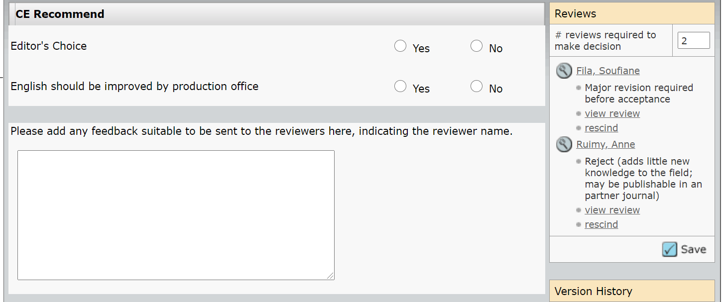
This will open up a pop-up window, showing you the reviewer’s Quality Rating Assessment, Recommendation and their report (either entered into the text box or uploaded as an attachment). You will also be able to rate the reviewer’s report in the Quality Assessment section at the bottom of the pop-up.
(It is possible to rescind a referee’s report by clicking ‘rescind’, but please do contact the EPL Admin if you would like to do so.)
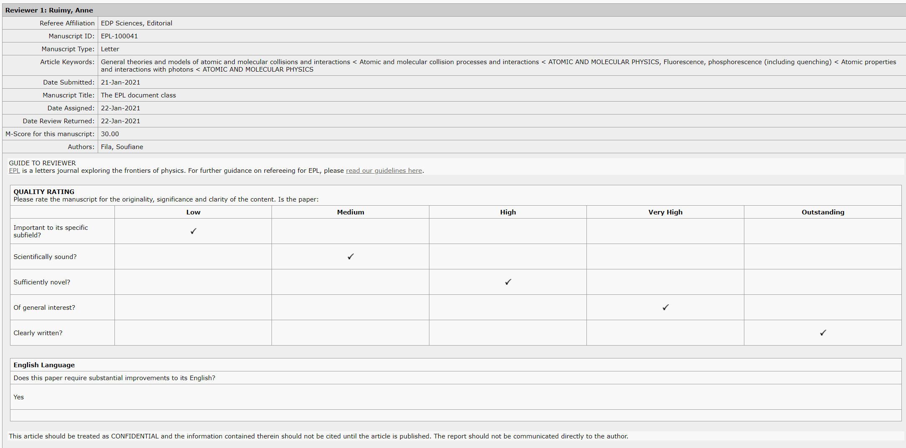
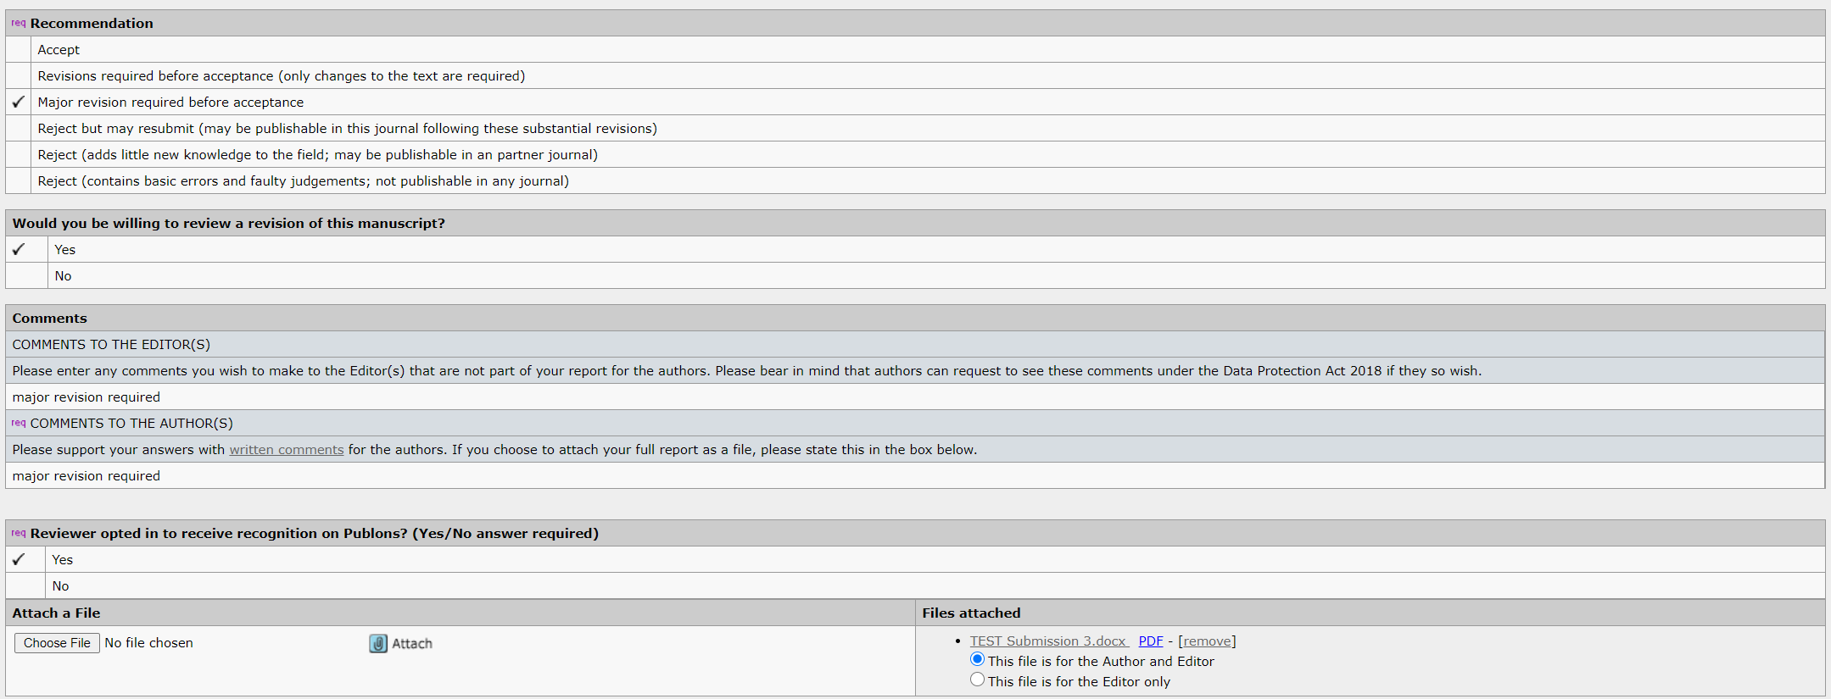
When rating a report, there are five quality assessment options to choose from:
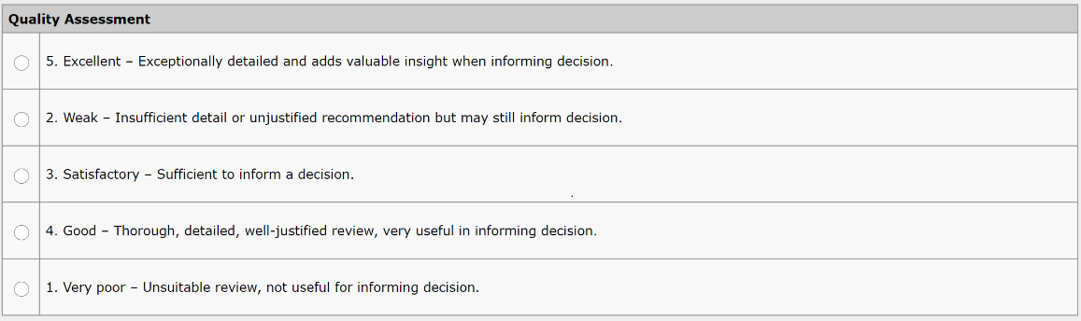
After you have made your assessment, please click ‘Save’.
The rating that you give a report will feed into the reviewer’s R-Score (see page 21 for an explanation of what the ‘R-Score’ is and where to find it). The R-Score will be displayed in the reviewer’s account. If you are unsure of how to rate the report, please contact the EPL admin team.

4.3 Making a recommendation
After you have viewed the reports and entered your comments into the text boxes, you can proceed with making your recommendation. To make your recommendation, click on the relevant ‘decision’ button:
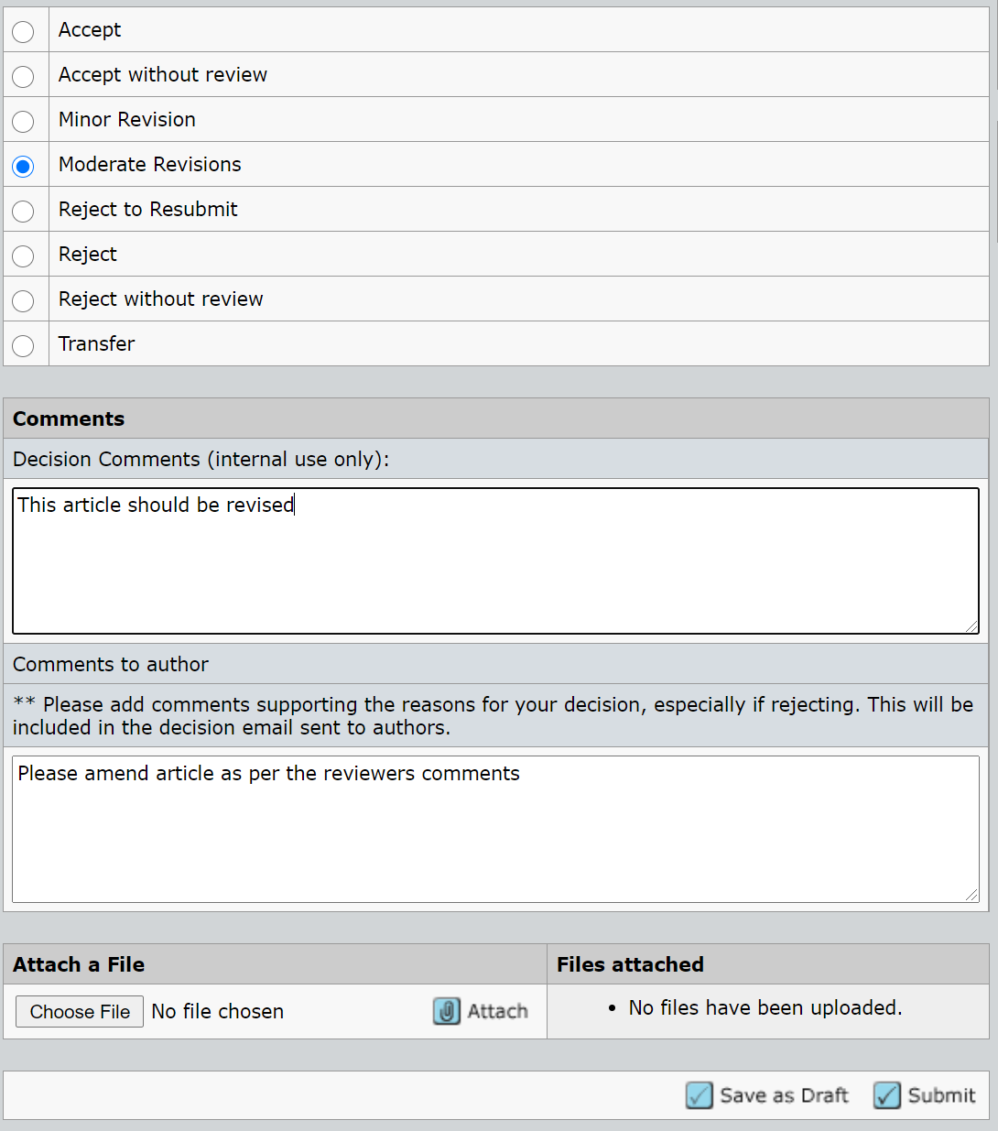
- Please also ensure that the reviewers’ names are not included on the report.
- If for any reason you need to edit a file or report, please contact the EPL admin.
- IMPORTANT! ACCEPT – This recommendation should ONLY be used when you are ready to accept an article for publication and the author does not need to make any further changes. If the author needs to make any further amendments, then please use another recommendation option.
- Please note that the ‘Decision Comments’ field is internal only and should only be used if you wish to highlight anything for EPL admin – comments entered in this field will not be available to the author.
- Please add comments that you have for the authors to the ‘Comments to the authors’ box, your comments are especially important if you are rejecting the article.
- The different decision emails can be viewed in the Appendix section (page 32)
After choosing the recommendation and adding your comments, click on the blue ‘Submit’ button at the bottom of the page to confirm it and pass across to the EPL Admin.

4.3.1 Making a recommendation – rejecting without sending article for peer-review
After an initial assessment of the article, you may have decided that it is not appropriate for peer-review and should be rejected immediately. To do this, click the ‘Reject without review’ option and add the reason for rejection to the ‘Decision Comments (internal use only) box so that the EPL admin will know which ‘reject without review’ email to send to the authors (the reject without review emails and options can be viewed in the Appendix section, page 47). Please also add any comments to the authors you have by typing in the ‘Comments to authors’ box.
Once you have added your comments, please click on the blue ‘Submit’ button to confirm your recommendation so that the EPL admin can confirm the decision and send the email to the authors.
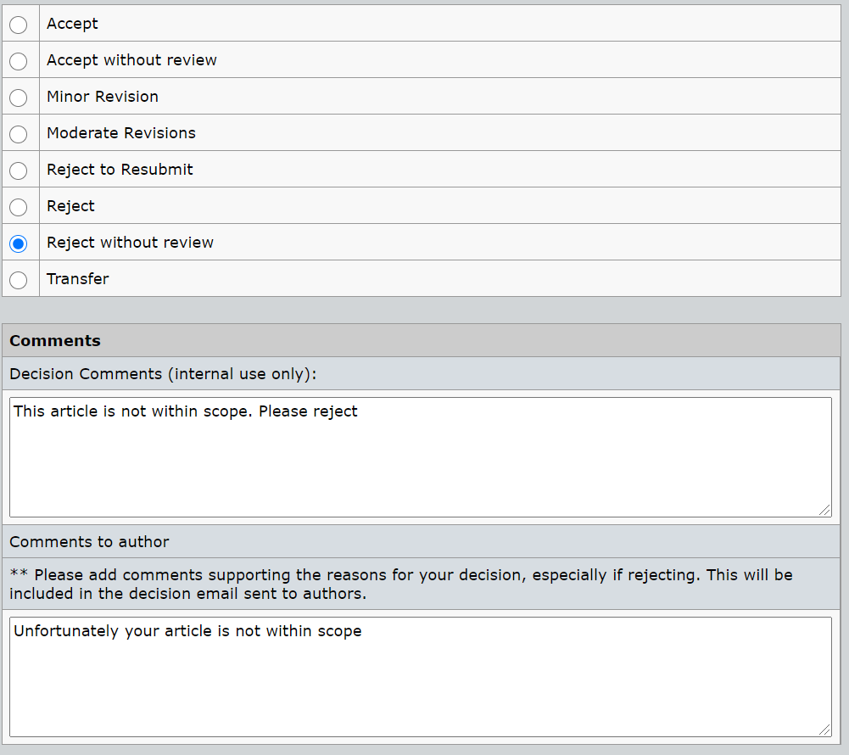

4.4 What if I am unable to make a recommendation based on the reports received?
You may find that the reports submitted are conflicting, or one (or both) of them may not be of a high enough quality to be used in making a recommendation. In these cases, you may want to obtain an additional report.
To the right of the of the screen you will note a field which allows you to edit how may reports are required (see below):
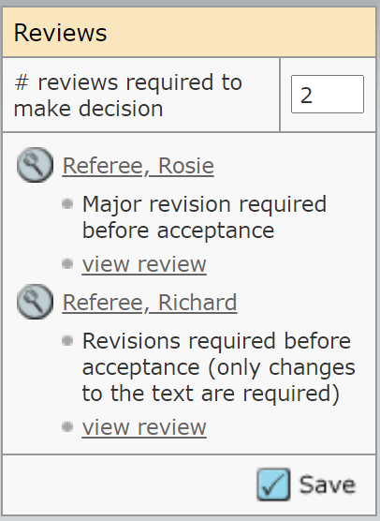
If you wanted to obtain an additional report increase the ‘# reviews required to make a decision’ from 2 to 3 before clicking on the blue ‘save’ button. This will allow you to invite an additional referee (note that you may need to add further referee selections if there are no alternative referees already available on the list).

5.0 Revised Articles

When a revised version gets submitted, the EPL Admin will complete several administrative checks before assigning it back to you. You will be alerted by an email from the EPL Admin, asking you to log into your account and access the revised article:
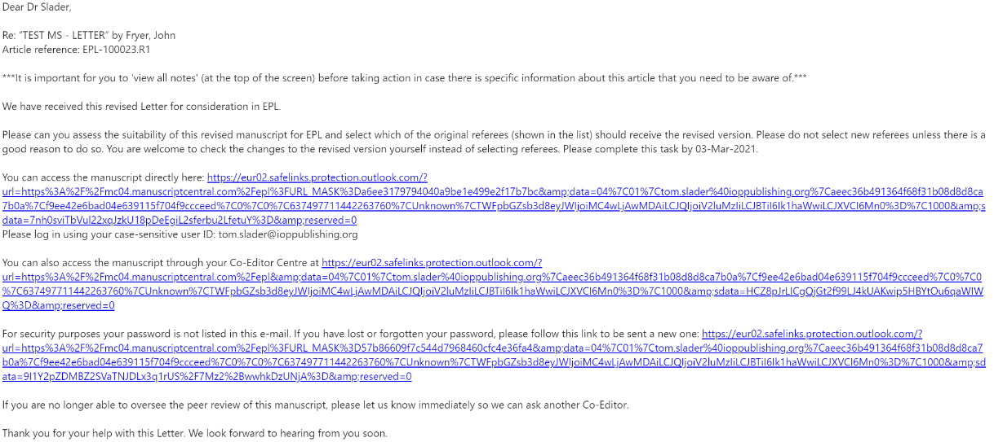
You can either access the article by clicking the links in the above email or you can access it by logging into your Co-Editor centre and clicking ‘Assign Referees’ in the ‘For Action – Revised Articles:
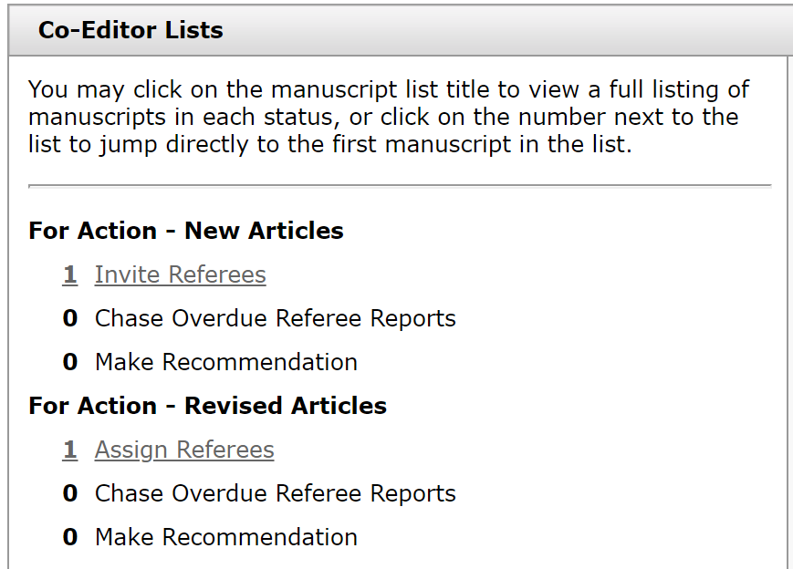
And then click the blue tick box to access the article:
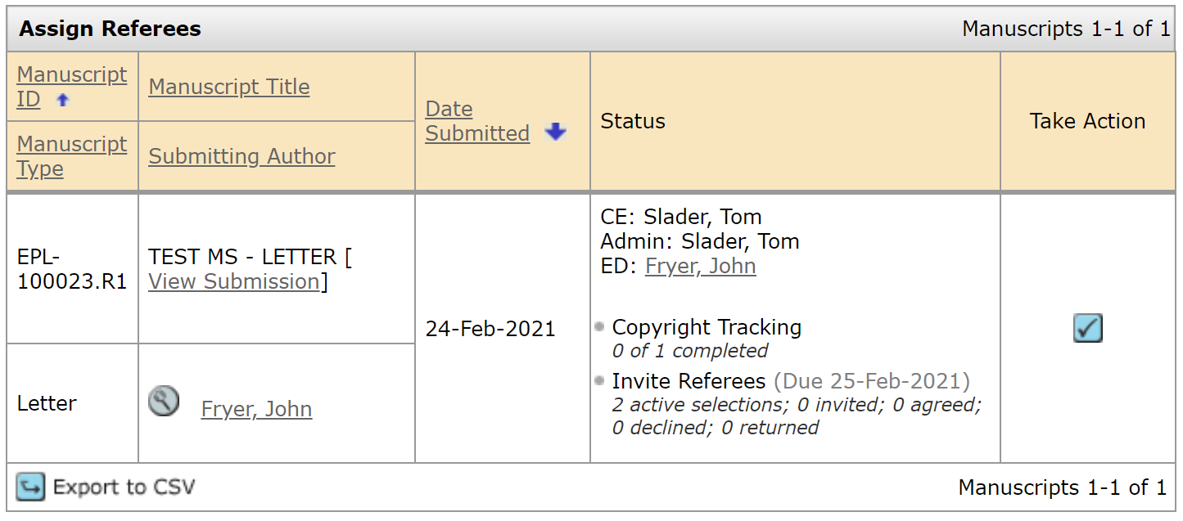
This will take you directly to ‘Invite Referees’ screen. Here you will be able to view the updated PDF, the authors’ responses, and reviewer reports on the original version of the article.
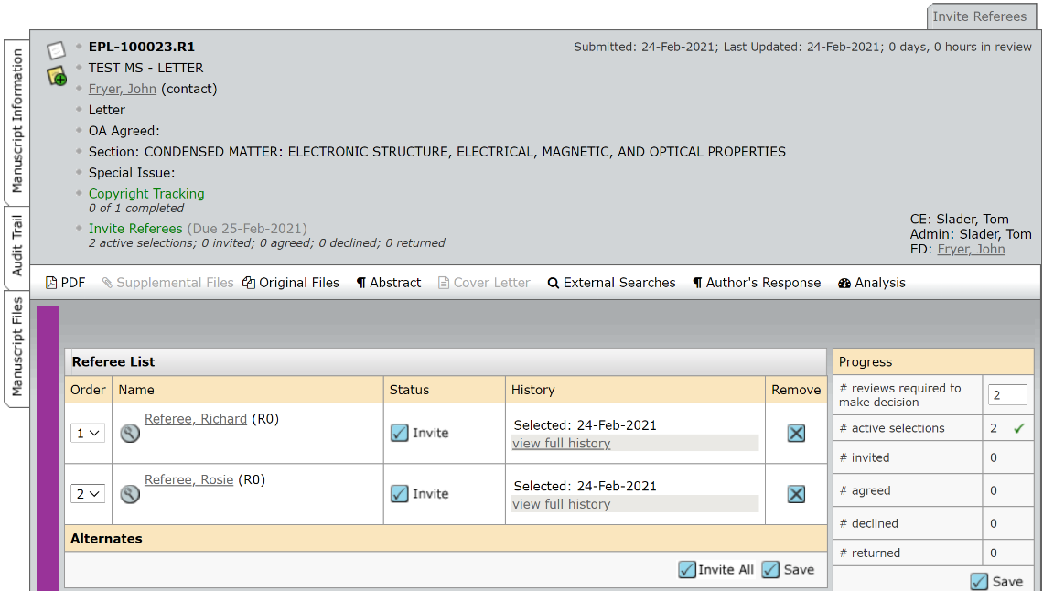
To view the PDF click the PDF button. And to view the Author’s Response click the Author’s Response link:
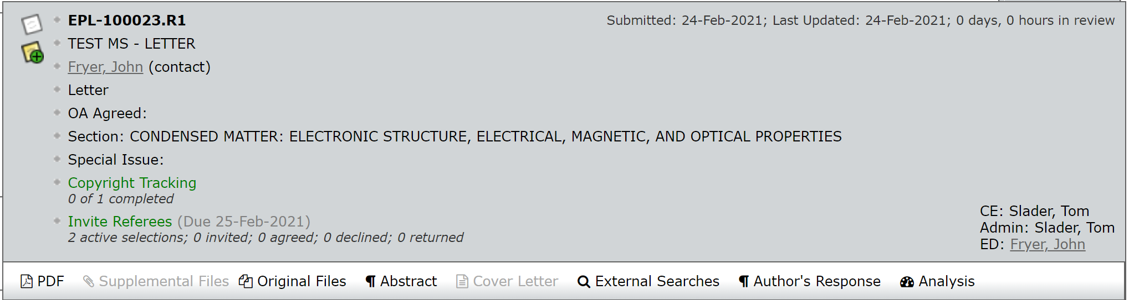
The previous reviewer reports and the decision comments can be viewed by clicking the ‘View Review Details’ link further down the page:
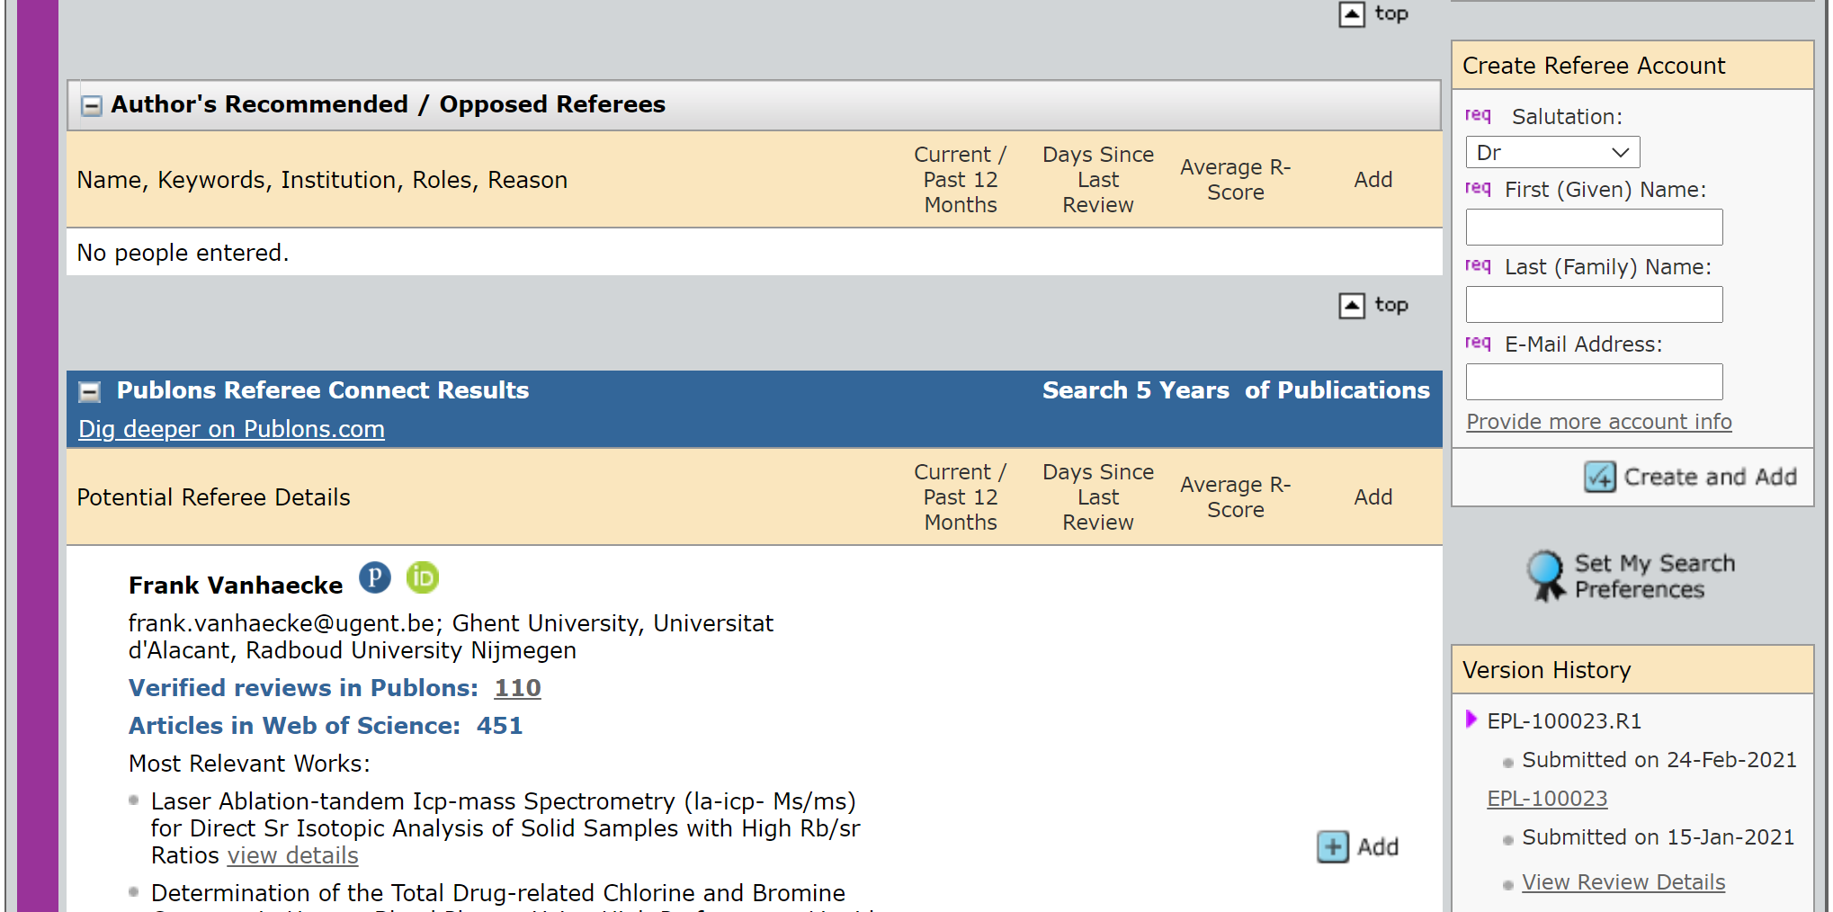
This will bring up a pop up that includes the reports on the original version (from the reviewers and the Co-Editor) and the decision email sent to the authors.
Next, you will need to decide which of the reviewers to send the article back to. To send the article back to the reviewers, click on the ‘Invite’ button next to their name:
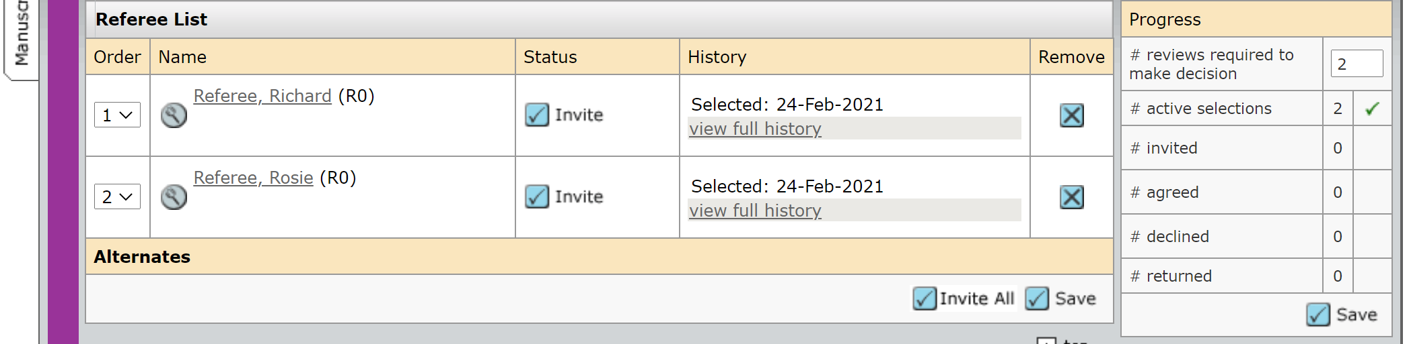
And click ‘Save and send’ in the pop-up email:
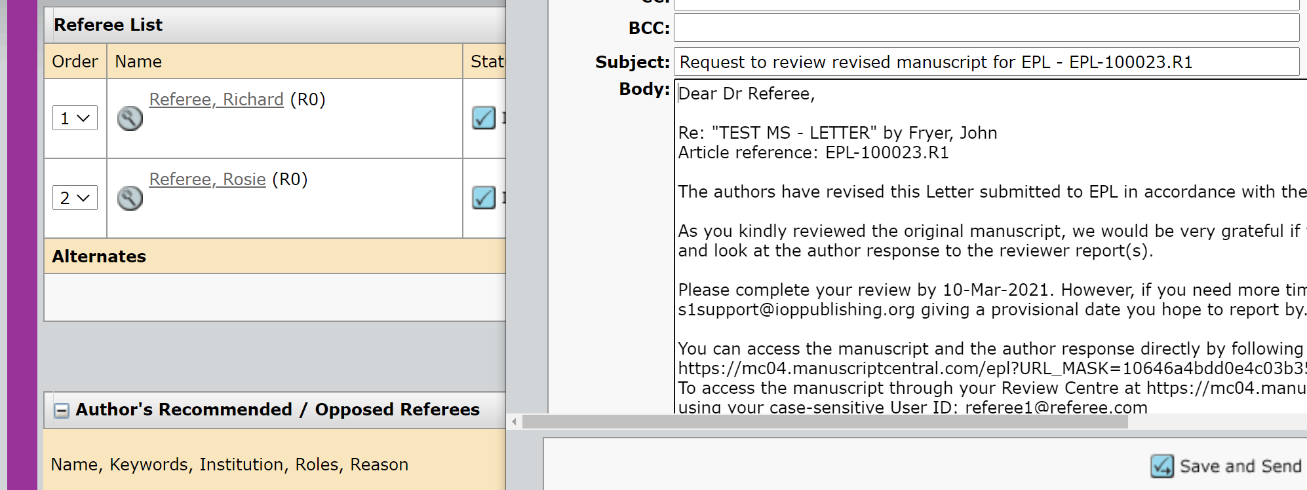
You will then have to activate the reviewer’s task. To do this, click ‘Agreed’ and then ‘Save’:
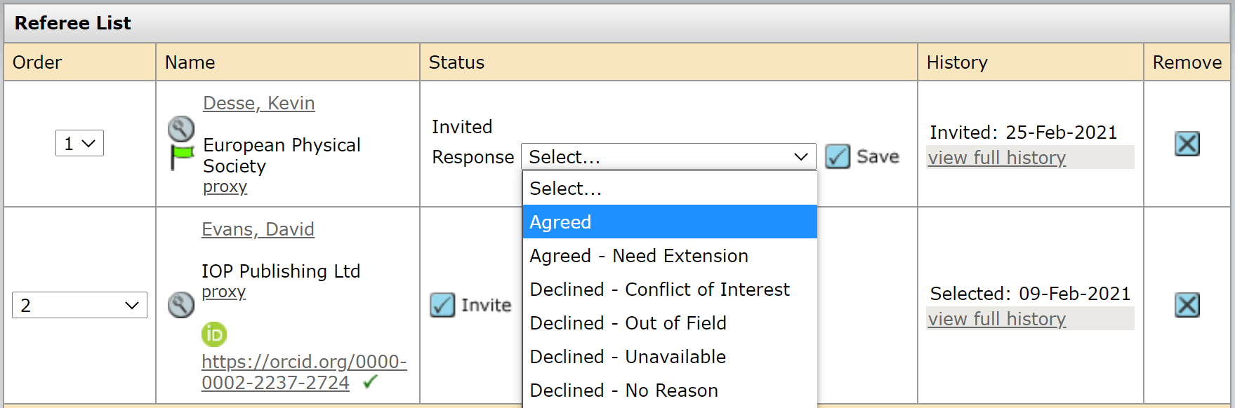
Then, in the email pop-up, select ‘Activate Referee’s Link’ from the dropdown box and click ‘Go’:
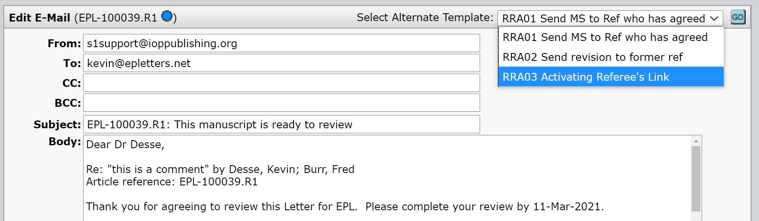
And then finally, click ‘Save and send’ to activate the reviewer’s task:
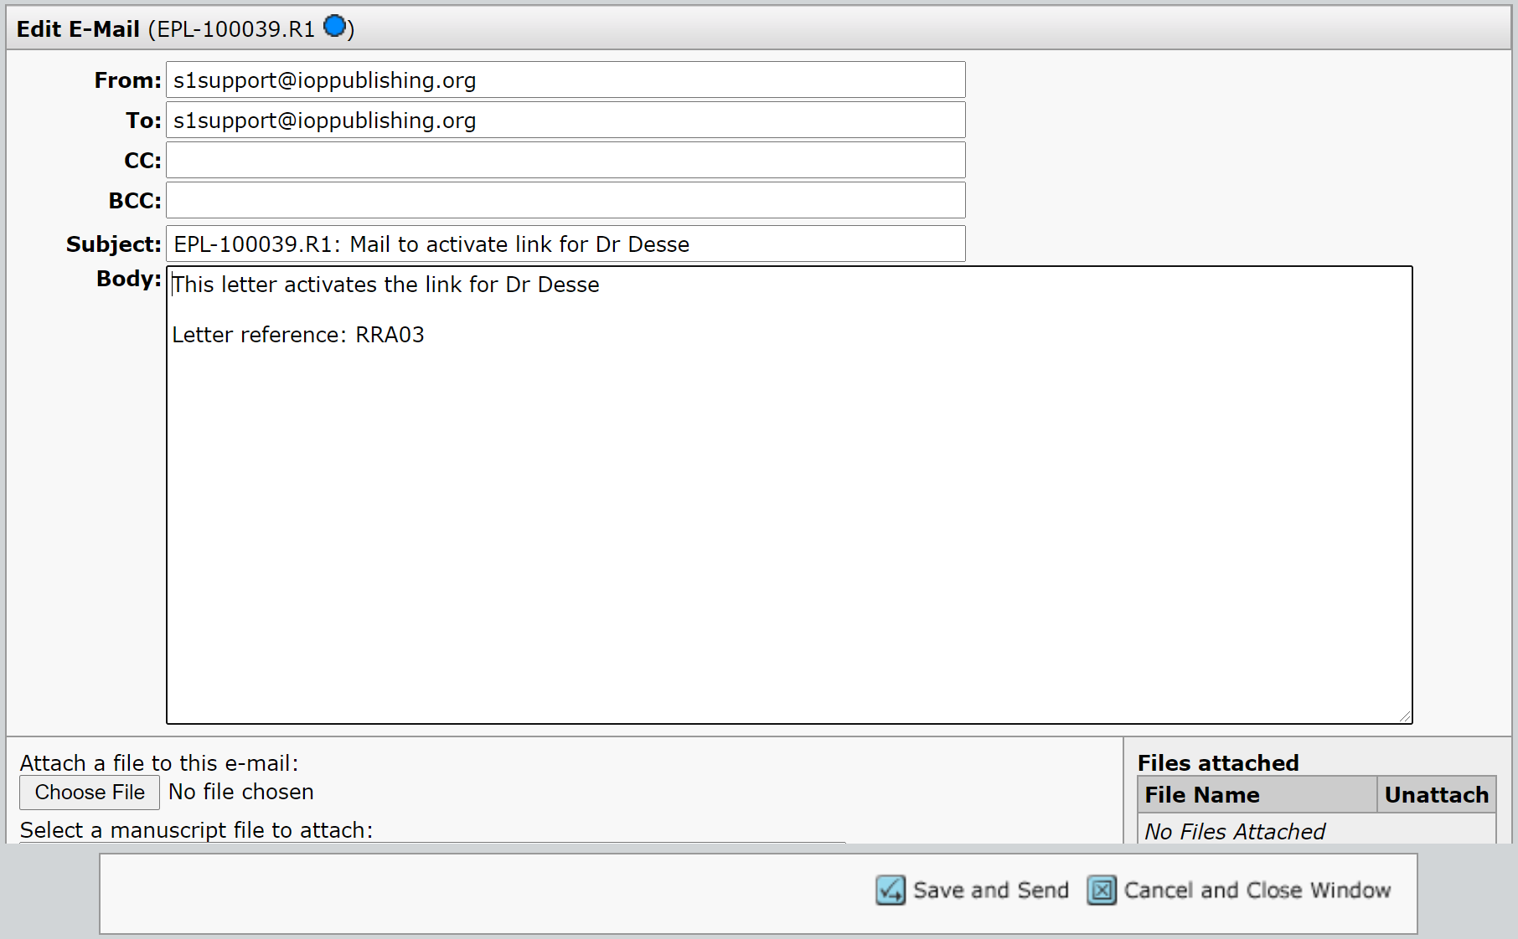
If you feel that the article only needs to go back to one reviewer, you will need to set the number of required reviewers to ‘1’ and click save:
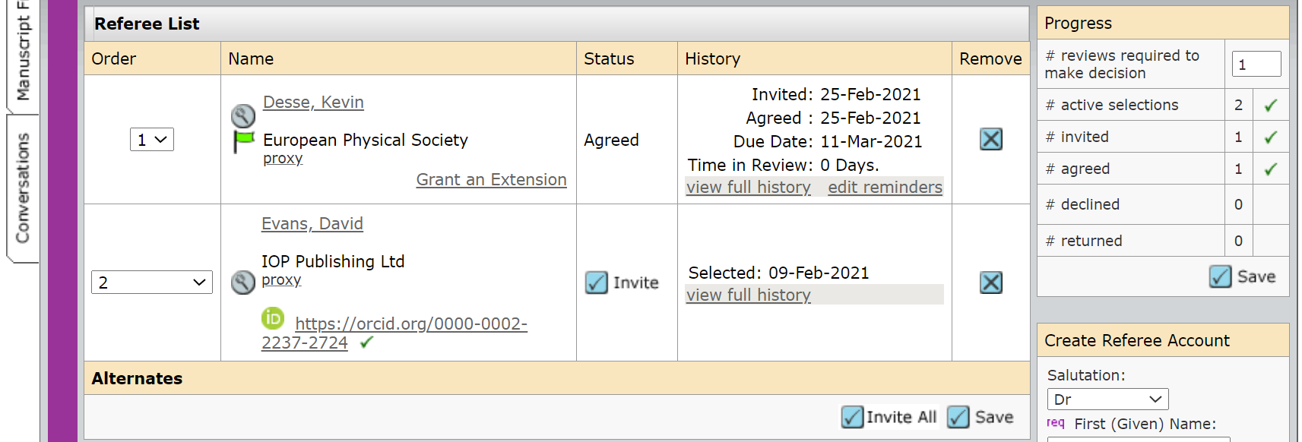
If you think that the article can be accepted without going back to the reviewers, please set the number of required reviews to ‘0’. This will take you directly to the ‘Make a Recommendation’ screen.
Please see the section below for information on making a recommendation on a revised article.

5.1 Revised Articles – Making a recommendation

Once the reviewers report on the revised article it will appear in the ‘Make Recommendation’ section of the ‘For Action – Revised Articles’ part of your work queue (see below). You will receive an automatic email alert informing you that you now have a task to complete:
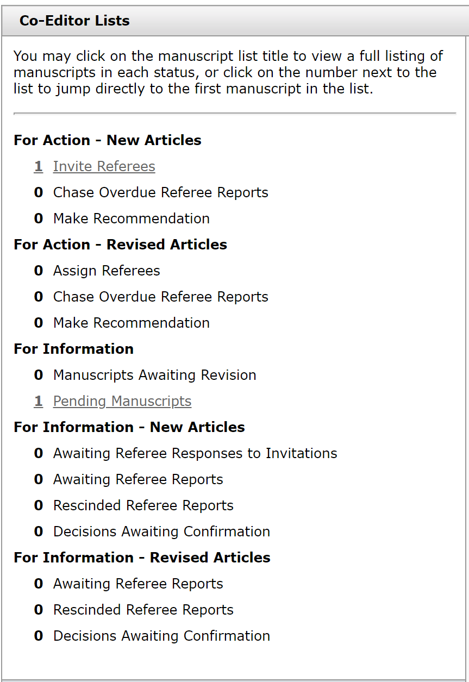
If you feel that the authors’ response to the reviewers will help you to make a recommendation, it can be located by clicking on the ‘Author’s Response’ button located in the information bar at the top of the article file (see below); 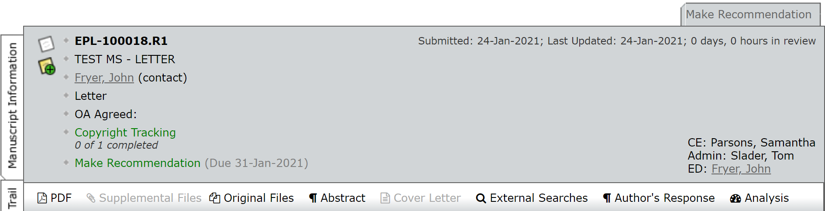
The recommendation-making process is then the same as for original papers, although we do not recommend selecting any new reviewers to review the revised version at this stage.
Revised versions can be sent back to the authors for further revision if appropriate or can be accepted depending on what the reviewers have recommended. Please note that any recommendation made will be sent to the EPL Admin to check before confirming it.
If you wish to include any comments for the EPL Admin, please use the ‘Decision Comments (internal use only)’ field.
To confirm your recommendation, click on the blue ‘Submit’ button.

6.0 For Information - New Articles and For Information - Revised Articles

You do not need to do anything to the articles that appear in these sections. The sections are intended to keep you informed of articles progress.
‘Manuscripts Awaiting Revisions’ indicates the articles that have had decisions made on them and are currently being revised by the authors.
‘Pending Manuscripts’ shows you all articles that have been assigned to you to act as a Co-Editor. These articles will be at any stage of the editorial process.
‘Awaiting Referee Responses to Invitations’ and ‘Awaiting Referee Reports’ are articles currently waiting for a reviewers input (either to agree or decline to report or to submit their report.
‘Rescinded Referee Reports’ are for reports that were submitted but have been returned to the reviewer for them to update or amend their review.
‘Decisions Awaiting Confirmation’ are articles where you have made a publication recommendation and is currently with the Admin for confirmation.
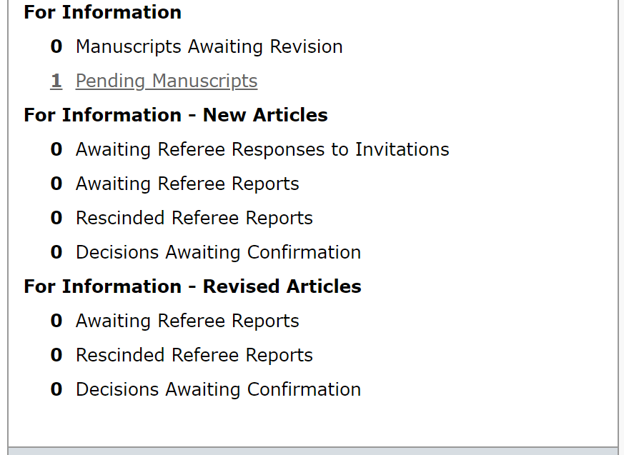

7.0 What if I need more help?

If you require any assistance at any stage of the review process, then please contact the EPL admin at editorial.office@epletters.net
NB: Although we will contact you when your assistance is required we recommend that you visit your Co-Editor Centre on a regular basis to check if any articles that are assigned to you require action.
If the EPL admin run out of reviewers for an article they will contact you and ask you to select and invite additional reviewers. If a recommendation becomes ‘overdue’ then they will send a reminder to you. In both cases we would be very grateful if you could take action as soon as possible so that we can maintain a high level of service to our authors.

8.0 Appendix - Decision emails

These are the decision emails that the EPL Admin team will send after you make your recommendation (see page 21). The emails will be populated with the author’s name, article title and article ID when sent by the EPL Admin.

8.1 Acceptance emails

8.1.1 Provisional acceptance:
Dear Dr Fryer,
Re: "TEST MS - LETTER" by Fryer, John
Article reference: EPL-100023
We are pleased to tell you that we have provisionally accepted your Letter for publication in EPL. Any further comments from the referees can be found below and/or attached to this message. Our editorial team will now perform some final checks to ensure that we have everything we need to publish your Letter. These checks will enable our production team to publish your Letter as quickly and efficiently as possible. Once this is confirmed, your article will be formally accepted and we will inform you of this via email.
If you have chosen to publish your Letter on an Open Access basis, you will be responsible for ensuring that the article publication charge (APC) is paid in full. Once your Letter has been accepted, we will not be able to change the Open Access status of your manuscript.
Thank you for choosing to publish in EPL. We look forward to publishing your Letter.
Yours sincerely
Tom Slader:
On behalf of:
Dr Tom Slader
EPL Editorial Office
European Physical Society
6 rue des Frères Lumière
F - 68200 Mulhouse
tel/fax: + 33 389 32 94 44 / + 33 389 32 94 49
email: editorial.office@epletters.net
web: https://www.epletters.net
Twitter: @epl_journal
Reviewer(s)' Comments to Author:
Referee: 1
Referee comments to author(s)
Please accpet the article
Referee: 2
Referee comments to author(s)
Please accept the article
EPL Admin Comments:
Comments to author(s):
(There are no comments.)
Co-Editor: This section will be populated with your name
Comments to author:
I agree with the reviewers. It should be accepted.

8.1.2 Formal Accept:
Dear Dr Fryer,
Re: "TEST MS - LETTER" by Fryer, John
Article reference: EPL-100023
We are pleased to inform you that your manuscript entitled "TEST MS - LETTER" by Fryer, John has been accepted for publication in EPL, as decided by the Co-Editor responsible, Dr Tom Slader.
PROOFS: The Production Office staff will contact you within the next days and inform you on the expected dispatch date of the proofs of your article.
Note that the e-mail will be sent to you (as corresponding author) and that a 48 HOURS LIMIT for checking and returning the proofs will have to be adhered to.
In case you might not be available, processing times will be much reduced if you can provide a second email address where we can contact you.
Remember that at this stage ONLY SMALL CORRECTIONS THAT DO NOT MODIFY THE CONTENT can be accepted. Since such modifications will be made directly on the files we already hold, revised or corrected electronic files should not be submitted at this stage.
Instead of the usual offprints, the .pdf file of the published version will be sent to you.
If you have chosen to publish your Letter on an open access basis, or if there are other charges related to your Letter you will receive an email with details on how to pay within the next few days.
Thank you for choosing to publish in EPL. We look forward to publishing your Letter.
Yours sincerely
Mr Frederic Burr
EPL Staff Editor
Mr Kevin Desse
EPL Editorial Assistant
On behalf of:
Co-Editor – Your name will appear here
EPL Editorial Office
European Physical Society
6 rue des Frères Lumière
F - 68200 Mulhouse
tel/fax: + 33 389 32 94 44 / + 33 389 32 94 49
email: editorial.office@epletters.net
web: https://www.epletters.net
Twitter: @epl_journal

Letter reference: DSA03

8.1.3 Accept without review:
Dear Dr Fryer,
Re: "TEST MS - LETTER" by Fryer, John
Article reference: EPL-100023
We are pleased to inform you that your manuscript entitled "TEST MS - LETTER" by Fryer, John has been accepted for publication in EPL, as decided by the Co-Editor responsible, Dr Tom Slader.
PROOFS: The Production Office staff will contact you within the next days and inform you on the expected dispatch date of the proofs of your article.
Note that the e-mail will be sent to you (as corresponding author) and that a 48 HOURS LIMIT for checking and returning the proofs will have to be adhered to.
In case you might not be available, processing times will be much reduced if you can provide a second email address where we can contact you.
Remember that at this stage ONLY SMALL CORRECTIONS THAT DO NOT MODIFY THE CONTENT can be accepted. Since such modifications will be made directly on the files we already hold, revised or corrected electronic files should not be submitted at this stage.
Instead of the usual offprints, the .pdf file of the published version will be sent to you.
If you have chosen to publish your Letter on an open access basis, or if there are other charges related to your Letter you will receive an email with details on how to pay within the next few days.
Thank you for choosing to publish in EPL. We look forward to publishing your Letter.
Yours sincerely
Mr Frederic Burr
EPL Staff Editor
Mr Kevin Desse
EPL Editorial Assistant
On behalf of:
Co-Editor – Your name will appear here
EPL Editorial Office
European Physical Society
6 rue des Frères Lumière
F - 68200 Mulhouse
tel/fax: + 33 389 32 94 44 / + 33 389 32 94 49
email: editorial.office@epletters.net
web: https://www.epletters.net
Twitter: @epl_journal
Letter reference: ESANR01

8.2 Revision Emails:

8.2.1 Minor Revision:
Dear Dr Fryer:
Manuscript ID EPL-100023 entitled "TEST MS - LETTER" which you submitted to the EPL, has been reviewed.
The comments of the reviewer(s) are included at the bottom of this letter.
As you can see from the enclosed reports, both recommendations are essentially positive, but both reviewers made specific suggestions for improving your paper.
Please revise your manuscript according to the referees' recommendations and submit a revised version to the Editorial Office together with a summary of the changes made and a detailed response to all points of criticism, in particular ones you have not addressed by making changes to the manuscript.
The modified text should also be highlighted in the manuscript. If the file is in EPL style, please use the command \revision. For other LaTeX files and Word documents, please use standard commands/tools for highlighting the modified text.
---------
IMPORTANT NOTE:
From the date of this message you have FOUR WEEKS to send your revised manuscript back to the Editorial Office. If this time limit is not adhered to, your submission may be considered as withdrawn and a new submission date may be assigned to the paper when it is resubmitted.
---------
Please take care to remain within the 7 pages in two column A4 format and make sure to send us the source files together with a .pdf file.
Finally, please bear in mind that appropriate references should always be cited, and update them in the revised version of your manuscript as necessary.
When preparing your revised manuscript, please note that the file requirements for submission include the following:
1. One complete PDF file which includes any figures and tables used, with the changes made in response to the reviewer comments highlighted.
2. One complete source file (the file used to create the PDF) which includes any figures and tables used. Please REMOVE any highlighting from this file after creating the PDF but before submitting it.
To revise your manuscript, log into https://mc04.manuscriptcentral.com/epl and enter your Author Center, where you will find your manuscript title listed under "Manuscripts with Decisions." Under "Actions," click on "Create a Revision." Your manuscript number has been appended to denote a revision.
You may also click the below link to start the revision process (or continue the process if you have already started your revision) for your manuscript. If you use the below link you will not be required to login to ScholarOne Manuscripts.
*** PLEASE NOTE: This is a two-step process. After clicking on the link, you will be directed to a webpage to confirm. ***
https://mc04.manuscriptcentral.com/epl?URL_MASK=f1c8825f60f64277aabba401e652d847
When submitting your revised manuscript, you will be able to respond to the comments made by the reviewer(s) in the space provided. You can use this space to document any changes you make to the original manuscript. In order to expedite the processing of the revised manuscript, please be as specific as possible in your response to the reviewer(s).
IMPORTANT: Your original files are available to you when you upload your revised manuscript. Please delete any redundant files before completing the submission.
Tex/Latex Files: Authors who have prepared their manuscript in Tex/LaTex format must submit files which will convert properly to PDF in the ScholarOne conversion engines. We strongly encourage all authors using Tex/LaTex to download the Clarivate ScholarOne Author guide for instructions and tips on preparing such files to ensure proper conversion to PDF.
https://clarivate.com/webofsciencegroup/download/40177/
Last but not Least: The journal production system pulls the titles and author names for accepted papers directly from the ScholarOne system. As such, please double check spelling and punctuation on the paper title and all author names during the submission of the revised paper to ensure that these are displayed correctly if your paper is accepted for publication.
Because we are trying to facilitate timely publication of manuscripts submitted to the EPL, your revised manuscript should be submitted by @@author due date will be populated when the email is sent@@. If it is not possible for you to submit your revision by this date, please contact us to request an extension of the revision period.
Once again, thank you for submitting your manuscript to the EPL and I look forward to receiving your revision.
Yours sincerely
Mr Frederic Burr
EPL Staff Editor
Mr Kevin Desse
EPL Editorial Assistant
On behalf of:
Dr Tom Slader
EPL Editorial Office
European Physical Society
6 rue des Frères Lumière
F - 68200 Mulhouse
tel/fax: + 33 389 32 94 44 / + 33 389 32 94 49
email: editorial.office@epletters.net
web: https://www.epletters.net
Twitter: @epl_journal
Reviewer(s)' Comments to Author:
Referee: 1
Referee comments to author(s)
This article is good. But should be revised slightly
Referee: 2
Referee comments to author(s)
This article is good, but should be revised
Co-Editor: Your name will appear here
Comments to author:
I agree with the reviewers. It should be revised.
Letter reference: DSMi01

8.2.2 Moderate Revision:
Dear Dr Fryer:
Manuscript ID EPL-100023 entitled "TEST MS - LETTER" which you submitted to the EPL, has been reviewed. The comments of the reviewer(s) are included at the bottom of this letter.
The attached reports contain points of criticism which are sufficiently adverse that the Co-editor, Dr Tom Slader, judged that the paper cannot be accepted in its present form.
If you feel that you can overcome or refute the criticism, you may submit a revised version.
Any resubmission should be accompanied by a summary of the changes made and a detailed response to all points of criticism, in particular ones you have not addressed by making changes in the manuscript.
The modified text should also be highlighted in the manuscript. If the file is in EPL style, please use the command \revision. For other LaTeX files and Word documents, please use standard commands/tools for highlighting the modified text.
---------
IMPORTANT NOTE:
From the date of this message you have FOUR WEEKS to send your revised manuscript back to the Editorial Office. If this time limit is not adhered to, your submission may be considered as withdrawn and a new submission date may be assigned to the paper when it is resubmitted.
---------
Please take care to remain within the 7 pages in two column A4 format.
Finally, please bear in mind that appropriate references should always be cited and update them in the revised version of your manuscript as necessary.
When preparing your revised manuscript, please note that the file requirements for submission include the following:
1. One complete PDF file which includes any figures and tables used, with the changes made in response to the reviewer comments highlighted.
2. One complete source file (the file used to create the PDF) which includes any figures and tables used. Please REMOVE any highlighting from this file after creating the PDF but before submitting it.
To revise your manuscript, log into https://mc04.manuscriptcentral.com/epl and enter your Author Center, where you will find your manuscript title listed under "Manuscripts with Decisions." Under "Actions," click on "Create a Revision." Your manuscript number has been appended to denote a revision.
You may also click the below link to start the revision process (or continue the process if you have already started your revision) for your manuscript. If you use the below link you will not be required to login to ScholarOne Manuscripts.
*** PLEASE NOTE: This is a two-step process. After clicking on the link, you will be directed to a webpage to confirm. ***
https://mc04.manuscriptcentral.com/epl?URL_MASK=10fd6e663af7400fa668b9fda400011e
When submitting your revised manuscript, you will be able to respond to the comments made by the reviewer(s) in the space provided. You can use this space to document any changes you make to the original manuscript. In order to expedite the processing of the revised manuscript, please be as specific as possible in your response to the reviewer(s).
IMPORTANT: Your original files are available to you when you upload your revised manuscript. Please delete any redundant files before completing the submission.
Tex/Latex Files: Authors who have prepared their manuscript in Tex/LaTex format must submit files which will convert properly to PDF in the ScholarOne conversion engines. We strongly encourage all authors using Tex/LaTex to download the Clarivate ScholarOne Author guide for instructions and tips on preparing such files to ensure proper conversion to PDF.
https://clarivate.com/webofsciencegroup/download/40177/
Last but not Least: The journal production system pulls the titles and author names for accepted papers directly from the ScholarOne system. As such, please double check spelling and punctuation on the paper title and all author names during the submission of the revised paper to ensure that these are displayed correctly if your paper is accepted for publication.
Because we are trying to facilitate timely publication of manuscripts submitted to the EPL, your revised manuscript should be submitted by @@author due date will be populated when the email is sent@@. If it is not possible for you to submit your revision by this date, please contact us to request an extension of the revision period.
Once again, thank you for submitting your manuscript to the EPL and I look forward to receiving your revision.
Yours sincerely
Mr Frederic Burr
EPL Staff Editor
Mr Kevin Desse
EPL Editorial Assistant
On behalf of:
Co-Editor – Your name will be here
EPL Editorial Office
European Physical Society
6 rue des Frères Lumière
F - 68200 Mulhouse
tel/fax: + 33 389 32 94 44 / + 33 389 32 94 49
email: editorial.office@epletters.net
web: https://www.epletters.net
Twitter: @epl_journal
Reviewer(s)' Comments to Author:
Referee: 1
Referee comments to author(s)
This article is good. But should be revised
Referee: 2
Referee comments to author(s)
This article is good, but should be revised
Co-Editor: Your name will appear here
Comments to author:
I agree with the reviewers. It should revised.
Letter reference: DSMo01

8.3 Rejection Emails:

8.3.1 Reject to Resubmit:
Dear Dr Fryer:
Manuscript ID EPL-100023 entitled "TEST MS - LETTER" which you submitted to the EPL, has been reviewed. The comments of the reviewer(s) are included at the bottom of this letter.
The attached reports contain points of criticism which are sufficiently adverse that the Co-editor, Dr Tom Slader, judged that the paper cannot be accepted in its present form.
If you feel that you can overcome or refute the criticism, you may submit a revised version.
Any resubmission should be accompanied by a summary of the changes made and a detailed response to all points of criticism, in particular ones you have not addressed by making changes in the manuscript.
The modified text should also be highlighted in the manuscript. If the file is in EPL style, please use the command \revision. For other LaTeX files and Word documents, please use standard commands/tools for highlighting the modified text.
---------
IMPORTANT NOTE:
From the date of this message you have FOUR WEEKS to send your revised manuscript back to the Editorial Office. If this time limit is not adhered to, your submission may be considered as withdrawn and a new submission date may be assigned to the paper when it is resubmitted.
---------
Please take care to remain within the 7 pages in two column A4 format.
Finally, please bear in mind that appropriate references should always be cited and update them in the revised version of your manuscript as necessary.
When preparing your revised manuscript, please note that the file requirements for submission include the following:
1. One complete PDF file which includes any figures and tables used, with the changes made in response to the reviewer comments highlighted.
2. One complete source file (the file used to create the PDF) which includes any figures and tables used. Please REMOVE any highlighting from this file after creating the PDF but before submitting it.
To revise your manuscript, log into https://mc04.manuscriptcentral.com/epl and enter your Author Center, where you will find your manuscript title listed under "Manuscripts with Decisions." Under "Actions," click on "Create a Revision." Your manuscript number has been appended to denote a revision.
You may also click the below link to start the revision process (or continue the process if you have already started your revision) for your manuscript. If you use the below link you will not be required to login to ScholarOne Manuscripts.
*** PLEASE NOTE: This is a two-step process. After clicking on the link, you will be directed to a webpage to confirm. ***
https://mc04.manuscriptcentral.com/epl?URL_MASK=10fd6e663af7400fa668b9fda400011e
When submitting your revised manuscript, you will be able to respond to the comments made by the reviewer(s) in the space provided. You can use this space to document any changes you make to the original manuscript. In order to expedite the processing of the revised manuscript, please be as specific as possible in your response to the reviewer(s).
IMPORTANT: Your original files are available to you when you upload your revised manuscript. Please delete any redundant files before completing the submission.
Tex/Latex Files: Authors who have prepared their manuscript in Tex/LaTex format must submit files which will convert properly to PDF in the ScholarOne conversion engines. We strongly encourage all authors using Tex/LaTex to download the Clarivate ScholarOne Author guide for instructions and tips on preparing such files to ensure proper conversion to PDF.
https://clarivate.com/webofsciencegroup/download/40177/
Last but not Least: The journal production system pulls the titles and author names for accepted papers directly from the ScholarOne system. As such, please double check spelling and punctuation on the paper title and all author names during the submission of the revised paper to ensure that these are displayed correctly if your paper is accepted for publication.
Because we are trying to facilitate timely publication of manuscripts submitted to the EPL, your revised manuscript should be submitted by @@author due date will be populated when the email is sent@@. If it is not possible for you to submit your revision by this date, please contact us to request an extension of the revision period.
Once again, thank you for submitting your manuscript to the EPL and I look forward to receiving your revision
Yours sincerely
Mr Frederic Burr
EPL Staff Editor
Mr Kevin Desse
EPL Editorial Assistant
On behalf of:
Co-Editor – Your name will appear here
EPL Editorial Office
European Physical Society
6 rue des Frères Lumière
F - 68200 Mulhouse
tel/fax: + 33 389 32 94 44 / + 33 389 32 94 49
email: editorial.office@epletters.net
web: https://www.epletters.net
Twitter: @epl_journal
Reviewer(s)' Comments to Author:
Referee: 1
Referee comments to author(s)
This article has potential. But is not good enough at this stage
Referee: 2
Referee comments to author(s)
This article is good, but needs a lot of revisions
Co-Editor:
Comments to author:
I agree with the reviewers. It should be rejected but with an allowance for resubmission.
Letter reference: DSMo01

Reject after review:
Dear Dr Fryer,
Re: "TEST MS - LETTER" by Fryer, John
Article reference: EPL-100023
Your Letter, submitted to EPL, has now been refereed and the referee report(s) can be found below and/or attached to this message.
I regret to inform you that, on the basis of the attached resulting report(s) and the Co-Editor's own expertise, we cannot accept your manuscript for publication.
We would like to thank you for your interest in EPL.
Yours sincerely
Mr Frederic Burr
EPL Staff Editor
Mr Kevin Desse
EPL Editorial Assistant
On behalf of:
Dr Tom Slader
EPL Editorial Office
European Physical Society
6 rue des Frères Lumière
F - 68200 Mulhouse
tel/fax: + 33 389 32 94 44 / + 33 389 32 94 49
email: editorial.office@epletters.net
web: https://www.epletters.net
Twitter: @epl_journal
Reviewer(s)' Comments to Author:
Referee: 1
Referee comments to author(s)
This article is not good enough and should be rejected
Referee: 2
Referee comments to author(s)
This article should be rejected
Co-Editor:
Comments to author:
I agree with the reviewers. It should be rejected.
Letter reference: DSR01

8.4 Reject without review emails

8.4.1 Reject without review (quality):
Dear Dr Fryer,
Re: "TEST MS - LETTER" by Fryer, John
Article reference: EPL-100023
Thank you for your submission to EPL.
To be publishable in this journal, articles must be of high quality and scientific interest, and be recognised as an important contribution to the literature.
Your Letter has been assessed and has been found not to meet these criteria. It therefore does not warrant publication in EPL and has been withdrawn from consideration.
We are sorry that we cannot respond more positively and wish you luck in publishing your article elsewhere.
Yours sincerely
Mr Frederic Burr
EPL Staff Editor
Mr Kevin Desse
EPL Editorial Assistant
On behalf of:
Co-Editor – Your name will be added here
EPL Editorial Office
European Physical Society
6 rue des Frères Lumière
F - 68200 Mulhouse
tel/fax: + 33 389 32 94 44 / + 33 389 32 94 49
email: editorial.office@epletters.net
web: https://www.epletters.net
Twitter: @epl_journal
Co-Editor:
Comments to author:
This article is not good enough for EPL. It should be rejected without being sent to reviewers.
Letter reference: DSRNR01

8.4.2 Reject without review (scope):
Dear Dr Fryer,
Re: "TEST MS - LETTER" by Fryer, John
Article reference: EPL-100023
Thank you for your submission to EPL. Unfortunately the content of your Letter is not within the scope of the journal. Your manuscript has therefore been withdrawn from consideration. If you would like to see a copy of the journal scope please visit the journal web page at https://iopscience.iop.org/journal/0295-5075/page/About-the-journal#scope.
We would like to thank you for your interest in EPL.
Yours sincerely
Mr Frederic Burr
EPL Staff Editor
Mr Kevin Desse
EPL Editorial Assistant
On behalf of:
Co-Editor – Your name will appear here
EPL Editorial Office
European Physical Society
6 rue des Frères Lumière
F - 68200 Mulhouse
tel/fax: + 33 389 32 94 44 / + 33 389 32 94 49
email: editorial.office@epletters.net
web: https://www.epletters.net
Twitter: @epl_journal
Reviewer(s)' Comments to Author:
Co-Editor: Slader, Tom
Comments to author:
This article is not within scope. Please reject
Letter Reference: DSR03

8.4.3 Reject without review (Poor English):
Dear Dr Fryer,
Re: "TEST MS - LETTER" by Fryer, John
Article reference: EPL-100023
We regret to inform you that the editors of EPL cannot consider your manuscript in its current form. All manuscripts submitted to the journal must be written in clear English so that readers are able to understand the meaning of the article. We strongly advise you to ask an English-speaking colleague to check your manuscript before submitting it.
If you decide to re-write your manuscript to make its meaning clear to the referees (many of whom do not speak English as their first language), we will be happy to reconsider it.
We thank you for your interest in EPL.
Yours sincerely
Mr Frederic Burr
EPL Staff Editor
Mr Kevin Desse
EPL Editorial Assistant
On behalf of:
Co-Editor – Your name will appear here
EPL Editorial Office
European Physical Society
6 rue des Frères Lumière
F - 68200 Mulhouse
tel/fax: + 33 389 32 94 44 / + 33 389 32 94 49
email: editorial.office@epletters.net
web: https://www.epletters.net
Twitter: @epl_journal
Co-Editor:
Comments to author:
This language must be improved before the article can be considered. Please reject.
Letter reference: DSR05

8.4.4 Reject without review (iThenticate/plagiarism):
Dear Dr Fryer,
Re: "TEST MS - LETTER" by Fryer, John
Article reference: EPL-100023
Thank you for your submission to EPL. In accordance with our ethical policy we routinely check manuscripts with the text comparison service iThenticate. We have found that your article contains text which appears to have been replicated from the following published articles:
***insert articles here***
Your manuscript has therefore been withdrawn from consideration. All manuscripts considered for publication in EPL should report substantial new results and should never contain any text directly copied from previously published work, even if that work is your own or is included for the benefit of the reader. If you would like more information about our ethical policy it is available at http://authors.iop.org/ethicalpolicy
We take breaches of our ethical policy very seriously and in the past have taken action against authors found to have breached these guidelines.
Yours sincerely
Tom Slader
EPL Editorial Office
European Physical Society
6 rue des Frères Lumière
F - 68200 Mulhouse
tel/fax: + 33 389 32 94 44 / + 33 389 32 94 49
email: editorial.office@epletters.net
web: https://www.epletters.net
Twitter: @epl_journal
Letter reference: DSR06

8.5 Reject and Transfer
Dear Dr Fryer,
Re: "TEST MS - LETTER" by Fryer, John
Article reference: EPL-100023
Your Letter, submitted to EPL, has now been refereed and the referee report(s) can be found below and/or attached to this message.
As you can see from their enclosed reports, both recognize a certain quality of your work but also agree that it lacks the degree of novelty required from a Letter.
I regret to inform you that on this basis we cannot accept your manuscript for publication.
A suitably modified and enlarged version, in which some of the questions raised by the referee(s) could be addressed more in depth, would most likely deserve publication in a specialized journal.
Note that in that respect EPL has an agreement of mutual transfer with different journals.
The complete list of partner journals can be found here:
https://www.epletters.net/physics-journal/agreement-with-other-journals/
This agreement allows, when appropriate, to transfer a manuscript together with the existing report(s) to one of these journals, keeping the original submission date.
PROCEDURE:
The transfer is not automatic and you should submit your revised paper formally to the Editorial Office of the journal receiving the transfer, mentioning previous consideration by EPL under the reference number.
It is also highly recommended to join a reply to the referee(s) when submitting the paper to the partner journal.
This possibility of transfer is valid within 4 months after the rejection of the paper by EPL.
The editorial transfer agreement respects the editorial independence of all journals involved in it. Therefore the editor of the other journal remains entirely free in his/her decisions and may decide to go through further review.
Please note that you can choose only one journal!!
We would like to thank you for your interest in EPL.
Yours sincerely
Mr Frederic Burr
EPL Staff Editor
Mr Kevin Desse
EPL Editorial Assistant
On behalf of:
Co-Editor – Your name will be added here
EPL Editorial Office
European Physical Society
6 rue des Frères Lumière
F - 68200 Mulhouse
tel/fax: + 33 389 32 94 44 / + 33 389 32 94 49
email: editorial.office@epletters.net
web: https://www.epletters.net
Twitter: @epl_journal
Reviewer(s)' Comments to Author:
Referee: 1
Referee comments to author(s)
This should be rejected
Referee: 2
Referee comments to author(s)
I don’t think this article is appropriate for EPL.
Co-Editor:
Comments to author:
This article is not good enough for EPL. It can be transferred to another journal
Letter reference: DSR13

9.0 Appendix - the iThenticate report
A high percentage of overlap does not always indicate ethical misconduct and a low percentage does not necessarily mean that the overlap is not concerning and can be ignored. Particularly close attention should be paid to portions of reproduced text in the Abstract, Results and Conclusions.

9.1 Abstract
- Loose collections of words/phrases: Indicator of possibly related articles in the published literature.
- Reproduced sentence: Clear indicator that this is very similar to a previous article.
- Reproduced paragraph: If a large portion of the abstract is reproduced, this indicates plagiarism.

9.2 Introduction
- Loose collections of words/phrases: Not too concerning as there is only a limited number of ways to introduce a subject for research and some common phrases are bound to be used again.
- Reproduced sentence: Again, this is not too concerning but it is worth checking the highlighted article to determine how serious this is.
- Reproduced paragraph: If this is from their own work, then it is usually an indication of laziness by the author.

9.3 Method
- Loose collections of words/phrases: Not too concerning but a useful way of identifying related works.
- Reproduced sentence: This can depend on the context. It may be a very common step in a widely used process, in which case this is perfectly permissible. If this supposed to be a unique or unusual section of the method, this hints at incremental publishing.
- Reproduced paragraph: Large reproduced sections of the method are usually a clear indication of incremental publishing.

9.4 Results and Discussion
- Loose collections of words/phrases: Not too concerning but a useful way of identifying related works.
- Reproduced sentence: This can depend on the context. It may be a common way to discuss or present the results, in which case this is permissible. If the results are supposed to be novel or unusual, this hints at incremental publishing and the highlighted work should be investigated. For figure captions, this may indicate figures and results in common with already published work and this should be investigated.
- Reproduced paragraph: Large reproduced sections of the results and discussion are a clear indication of incremental publishing.

9.5 Conclusions
- Loose collections of words/phrases: Check source to determine if this is makes sufficient advance.
- Reproduced sentence: A clear warning sign. Carefully check the source to determine if this is incremental work. Consider rejecting with a warning.
- Reproduced paragraph: Indicator of serious self-plagiarism.

10.0 Appendix - Searching by Keywords:
There are four types of keyword searches when searching for reviewers:
1) Exact match - it will search only for the entered keyword and return limited results.
2) Trailing wildcard* - (asterisk after the keyword - e.g. keyword*). Will include reviewers that have the searched for keyword and any phrase after it.
3) *leading wildcard - (asterisk before the keyword - e.g. *keyword). Will include reviewers that have the searched for keyword and any phrase before it.
4) A *combined wildcard* - includes both a leading and trailing wildcard (asterisk before and after the phrase - e.g. *keyword*). Will include reviewers that have the searched for keyword and any phrase before and after it.
Please note, the wildcard searches work in both the advanced search keywords and the related papers keywords search options.

10.1 Searching keywords, example one: ‘Relativistic wave equations’

10.1.1 Exact match
In this example, we are using ‘Relativistic wave equations’ from the author supplied keywords:
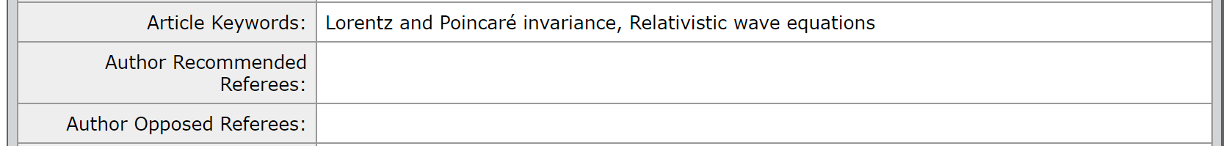
To search using the keywords, copy and paste them into the ‘Keywords’ section of the ‘Advanced Search’ box and click ‘Search’:
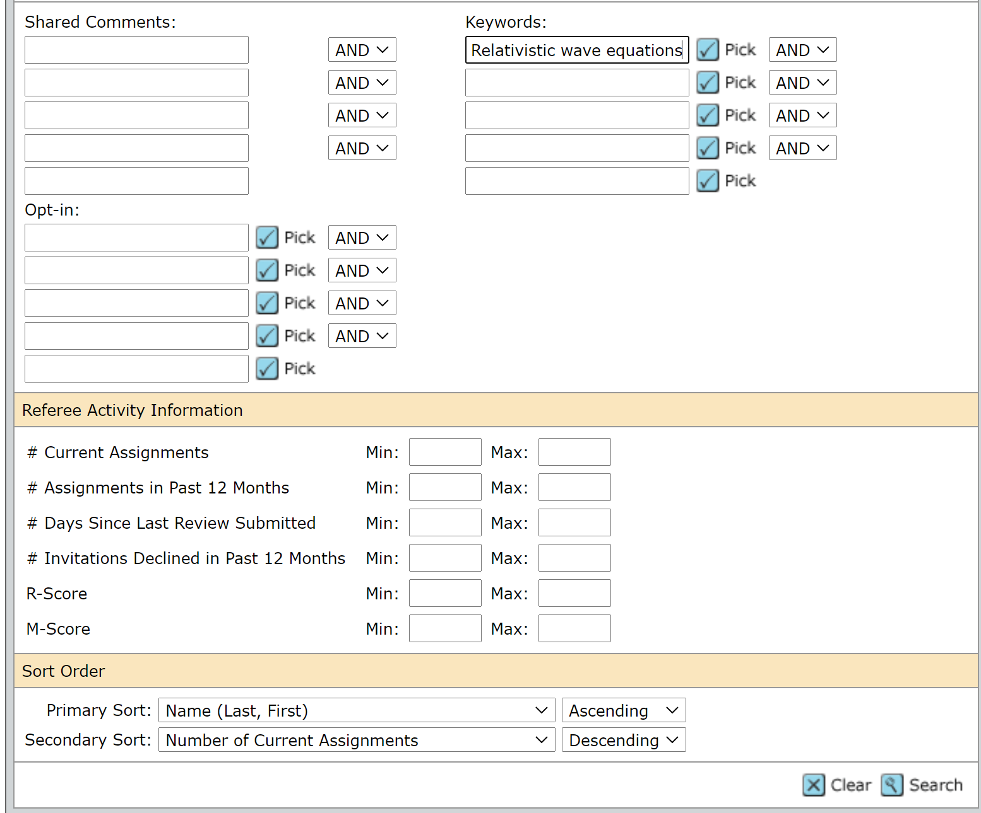
This will search the EPL database for any reviewers with ‘Realistic wave equations’ entered into their keywords:
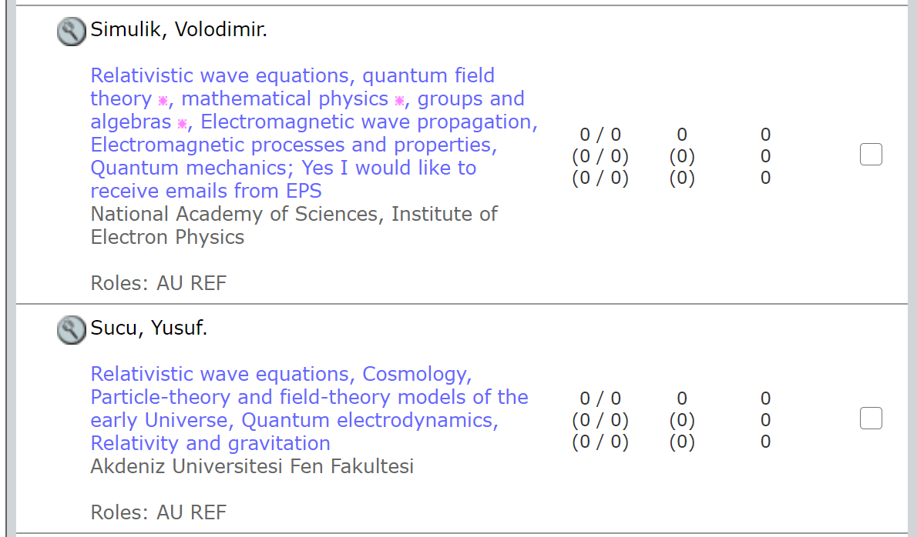
Please note that the results page will not display all the reviewer’s keywords (you may see that your searched keyword does not appear in the reviewer’s keyword list above), to view the reviewer’s full list of keywords, click on the magnifying glass next to their name.

10.1.2 Trailing wildcard
Add the wildcard after ‘Realistic wave equations’ to find results that include ‘Realistic wave equations’ but also include a phrase or keyword after the searched keyword:
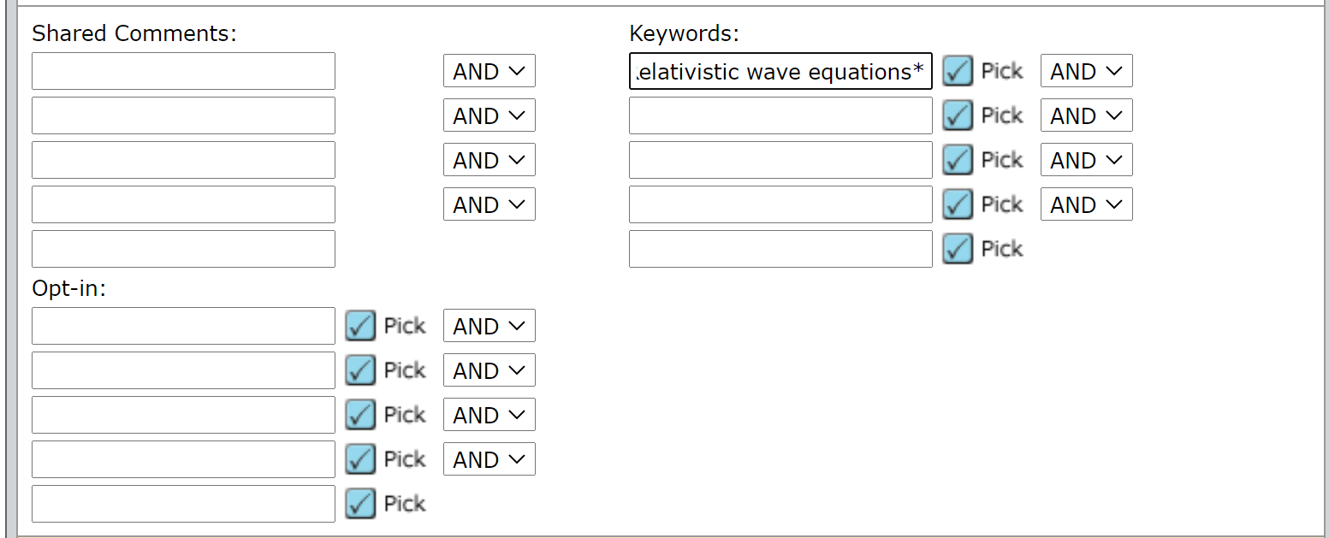
And again, click ‘Search’ to bring up the results.

10.1.3 Leading wildcard
Add the wild card before ‘Realistic wave equations’ to find results that include realistic wave equations but also include a phrase or keyword before the searched keyword:
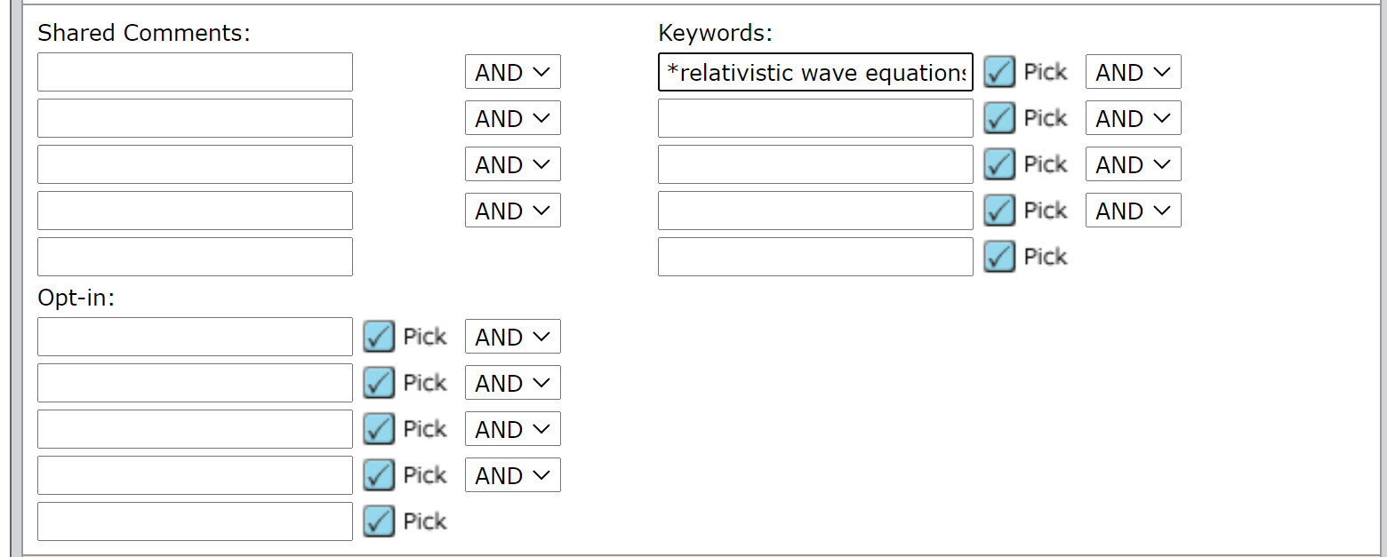
You can see that the search results will include reviewers that have ‘relativistic wave equations’ as a keyword but it will include an additional word or phrase before the searched for keyword (exact solutions of relativistic wave equations):
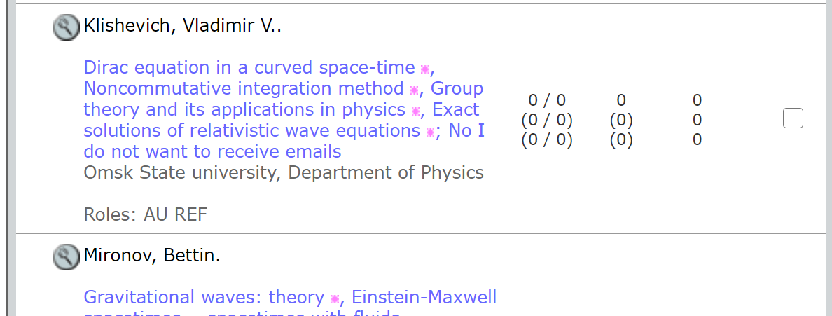

10.1.4 Combined wildcard search
Add the wild card before and after the searched keyword:
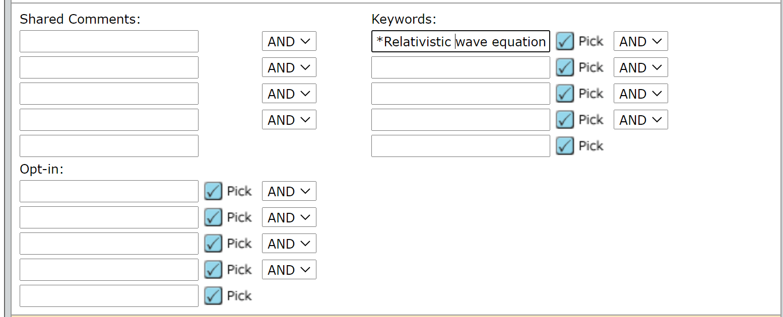
Here the results will include reviewers that have the keyword but will also include the keyword that includes phrases before and after it (Relativistic and non-relativistic wave equations. Quarkonium)
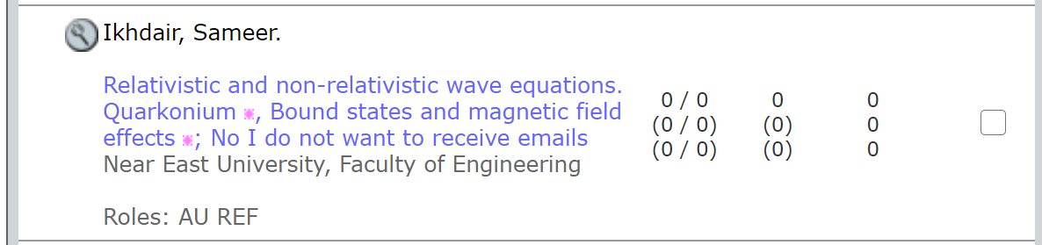
Please bear in mind that Combined wildcard searching will produce more results but may be less accurate.

10.2 Searching keywords, example two: ‘Perturbation theory’
In second example, we are using ‘Perturbation theory’ from the author supplied keywords:
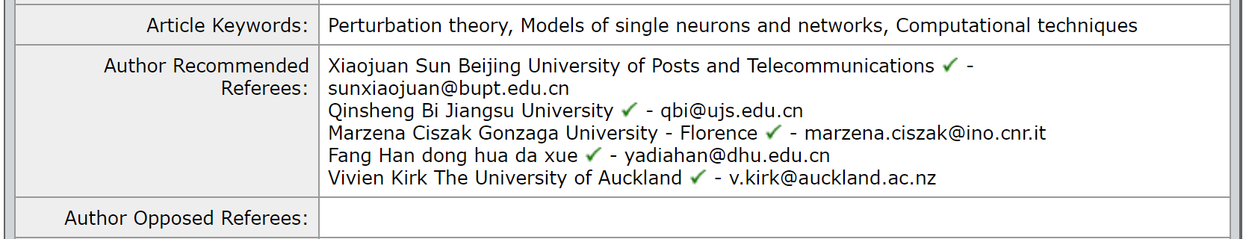

10.2.1 Exact match
Again, take the keyword that you wish to search and add it into the keyword search box:
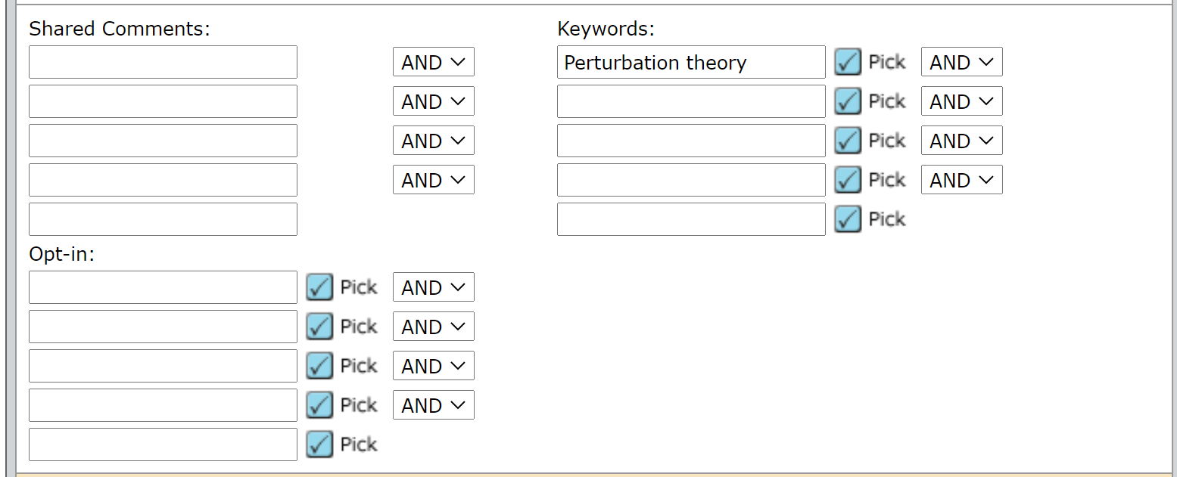
This will bring up an exact match of reviewers who have ‘Perturbation theory’ entered as a keyword:
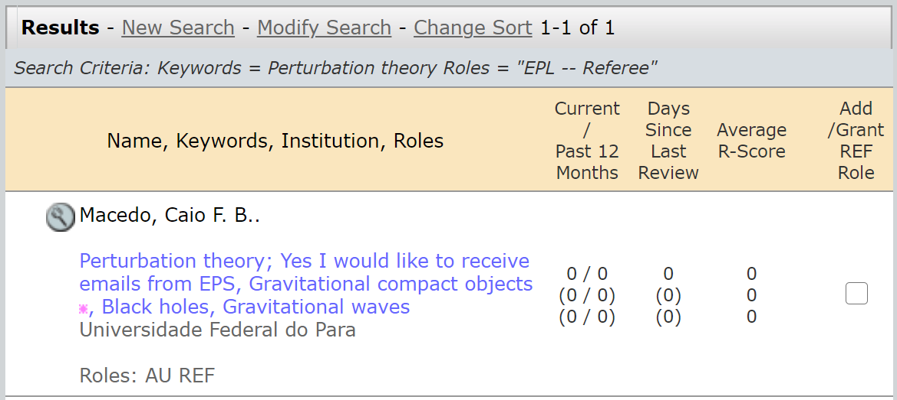

10.2.2 Trailing wildcard
Add the wildcard after ‘Perturbation theory’ to find results that include perturbation theory but also include a phrase or keyword after the searched keyword:
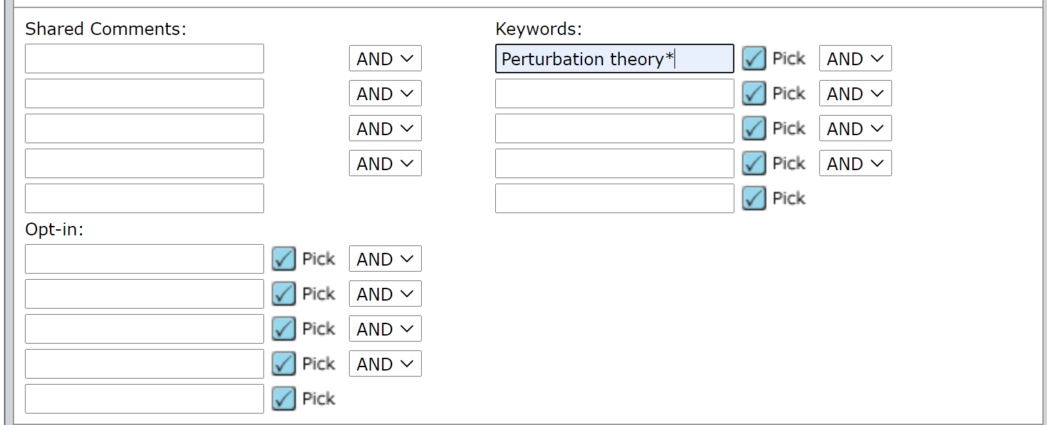
Here you will see that an additional reviewer has been found. The new reviewer’s result includes perturbation theory but includes ‘in relativity’ after the keyword that has been searched for (perturbation theory in relativity):
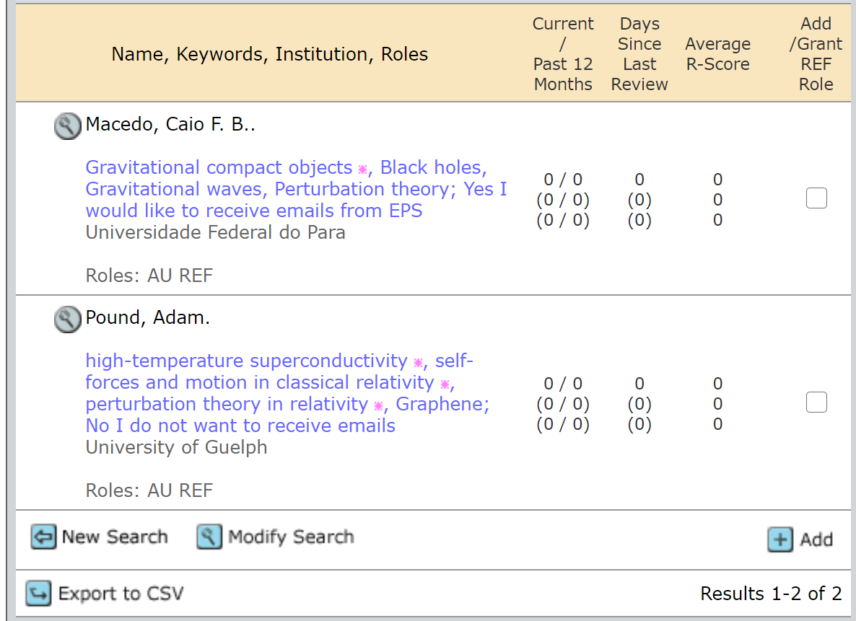

10.2.3 Leading wildcard
Add the wild card before ‘Perturbation theory’ to find results that include perturbation theory but also include a phrase or keyword before the searched keyword:
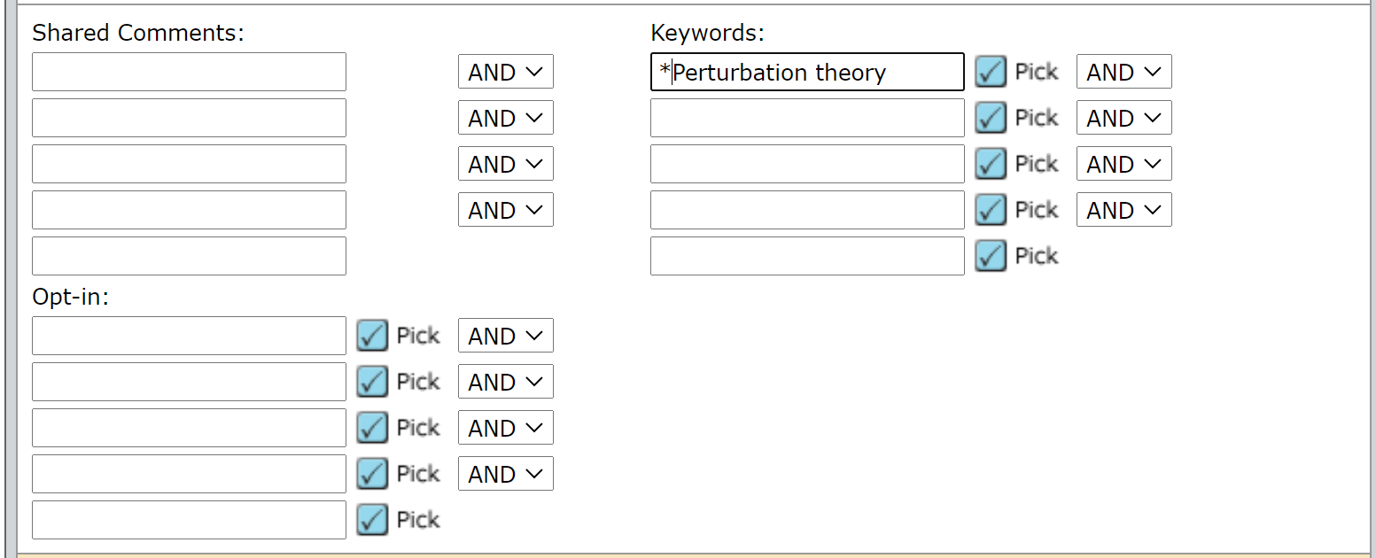
This search will include reviewers that have the exact match for perturbation theory in their Keywords but will also include reviewers who have a keyword or phrase before the searched for keyword. In the examples below you can see that the results now include results such as ‘chiral perturbation theory’ and ‘black hole perturbation theory’:
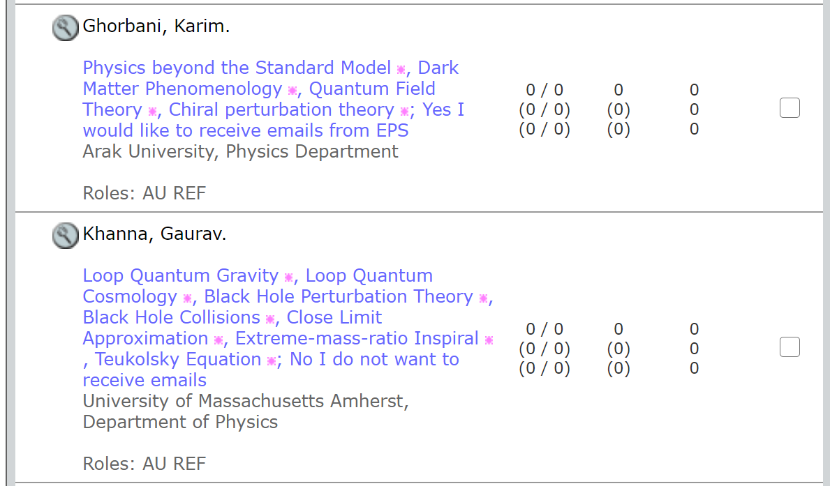

10.2.4 Combined wildcard search
Add the wild card before and after the searched keyword:
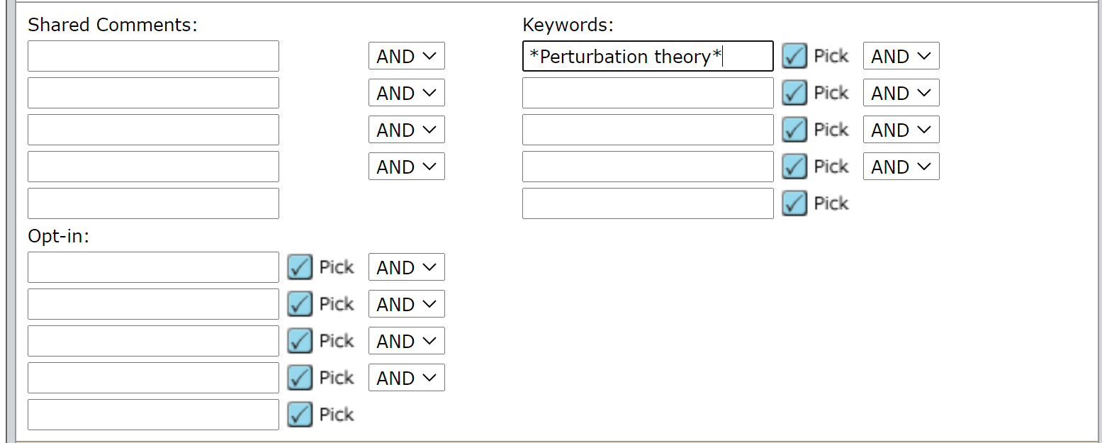
This will bring up reviewers who have terms before and after perturbation theory. Here you can see a reviewer has been added to the search results who has ‘theoretical aspect of cosmological perturbation theory at the time of inflation which helps us to understand the CMB anisotropy’ as a keyword:
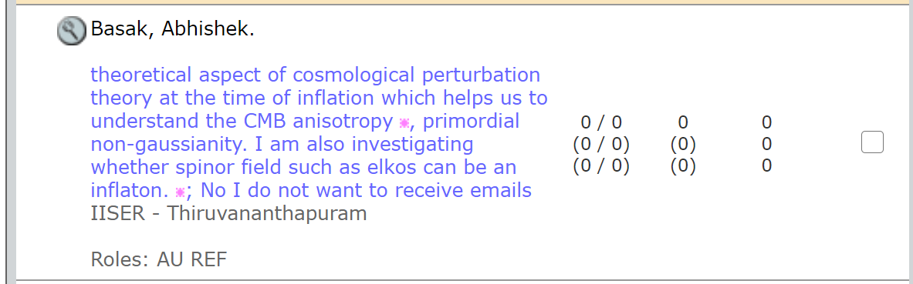
Please bear in mind that Combined wildcard searching will produce more results but may be less accurate, as you can see from the above search result.

